**HW-4**

**Multi-Region Serverless Application for Resilience and High Availability**

**GitHubLink:** [**https://github.com/ShilpaShivarudraiah/MultiRegion-Serverless-Workshop-1**](https://github.com/ShilpaShivarudraiah/MultiRegion-Serverless-Workshop-1)

**Step1: Creating IAM Policies by selecting Policies and clicking on the Create policy button to Create TicketGet Policy and TicketPost Policy**

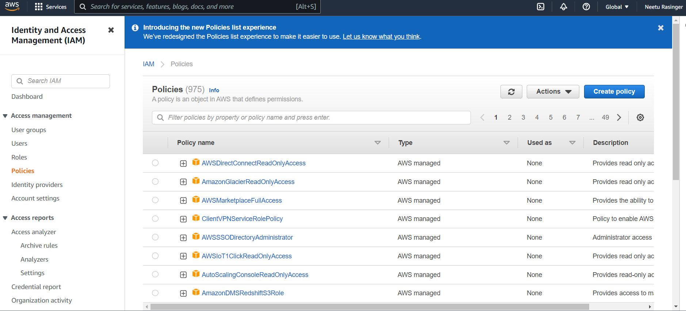

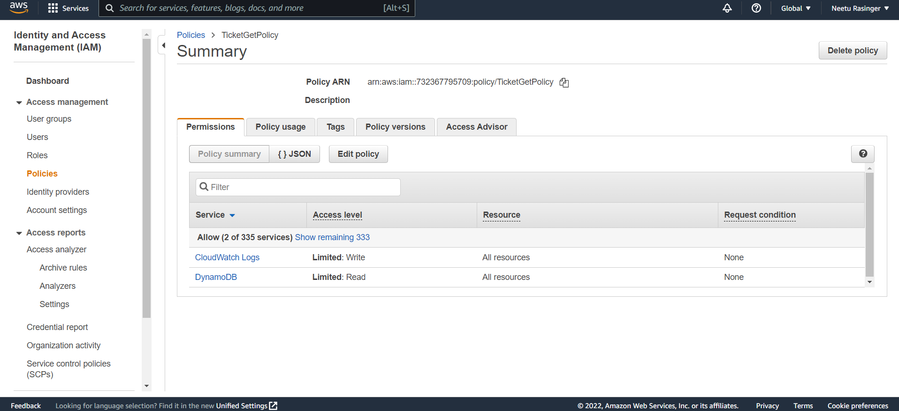

**Step 2: Creating the TicketPost Policy**

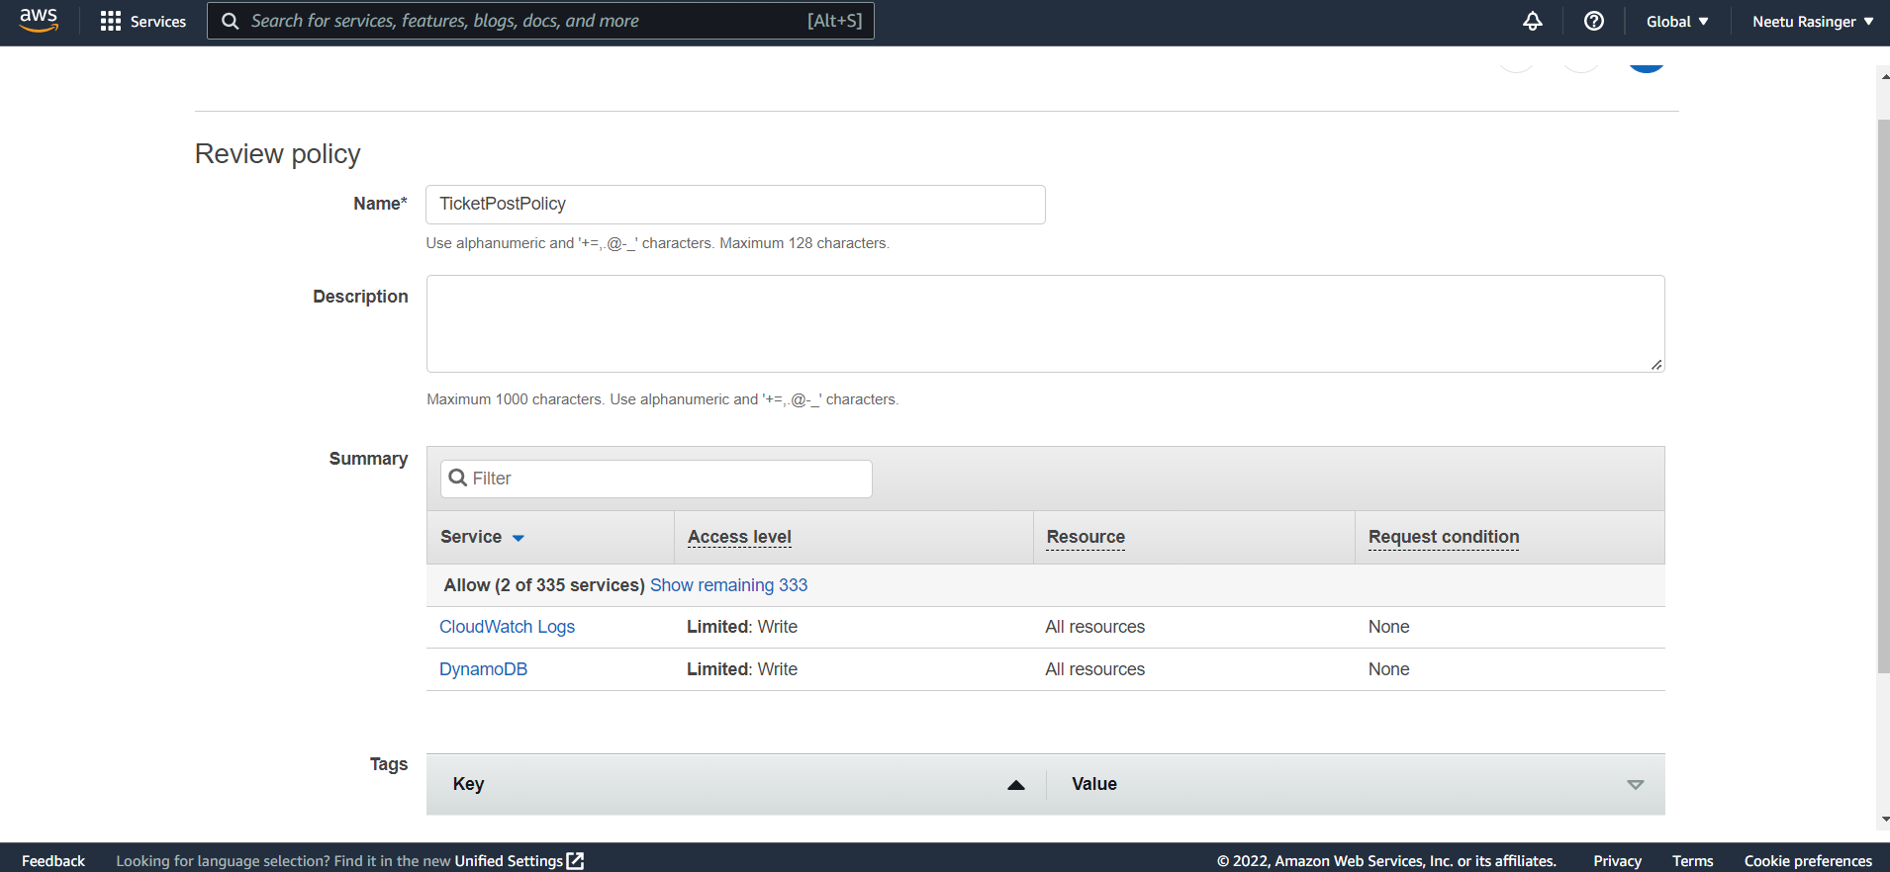

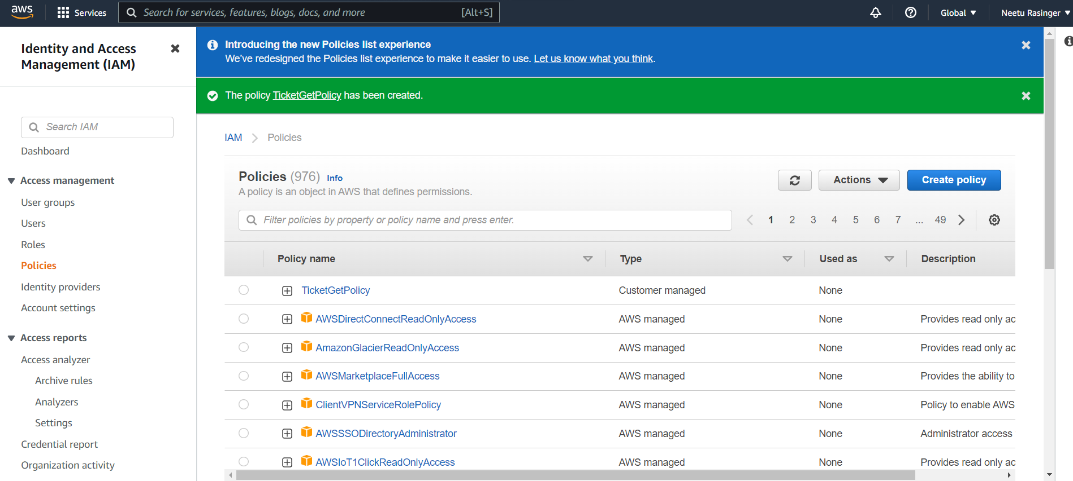

**Below is the screenshot of Policies Created**

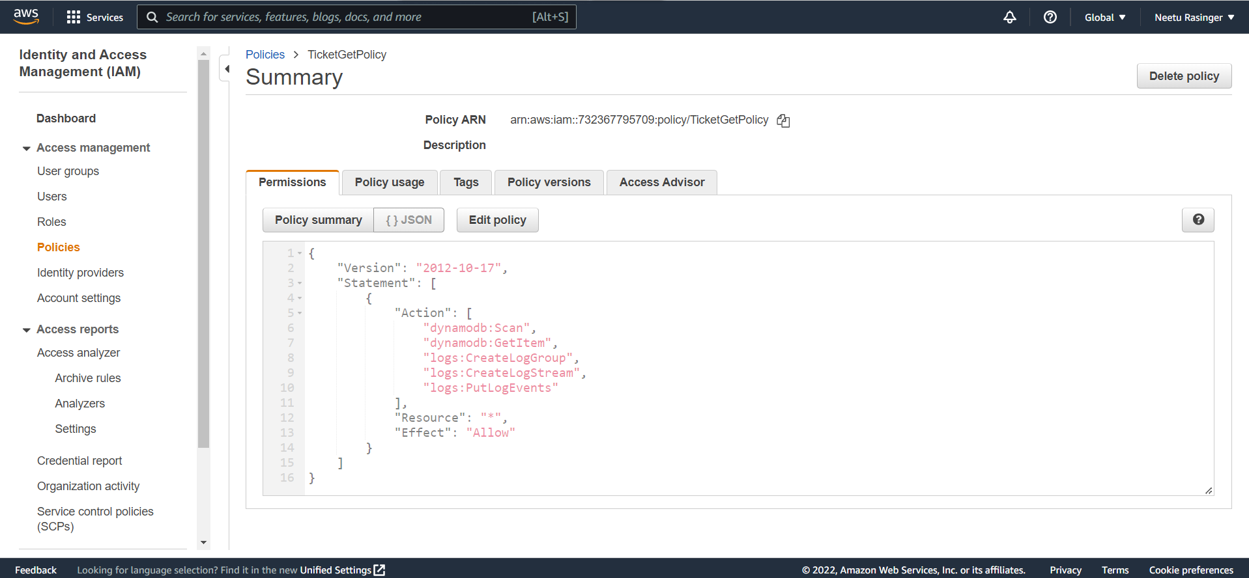

**Step 3: Creating Roles** **for both TicketGet policy and TicketPost policy created above.**

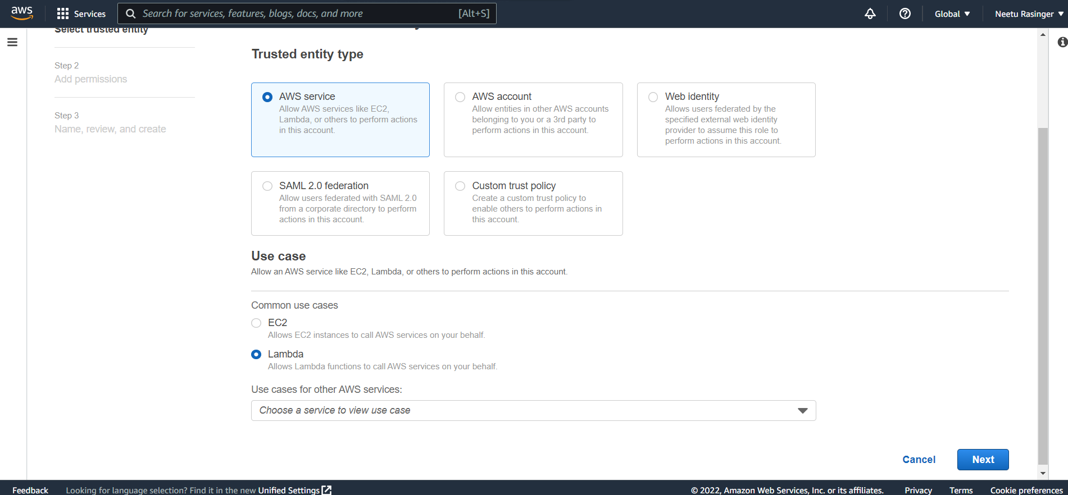

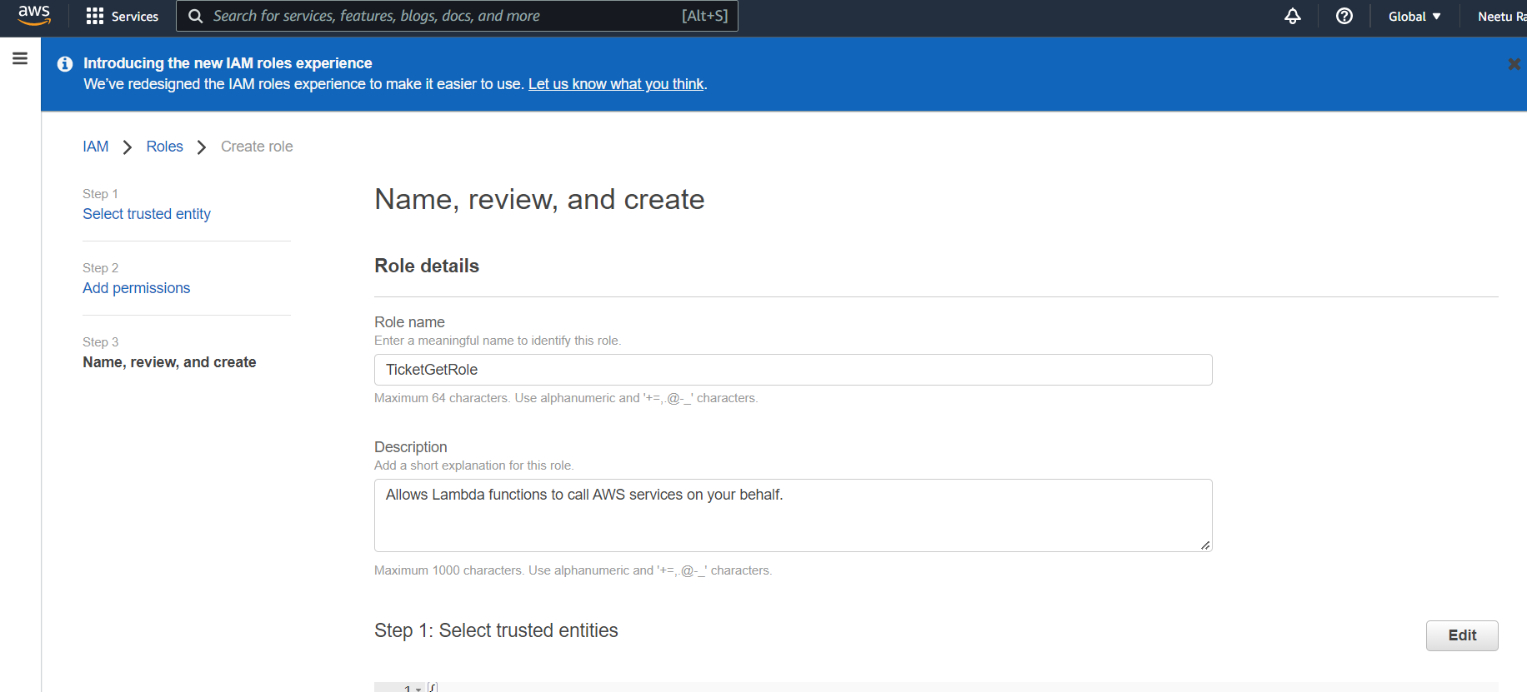

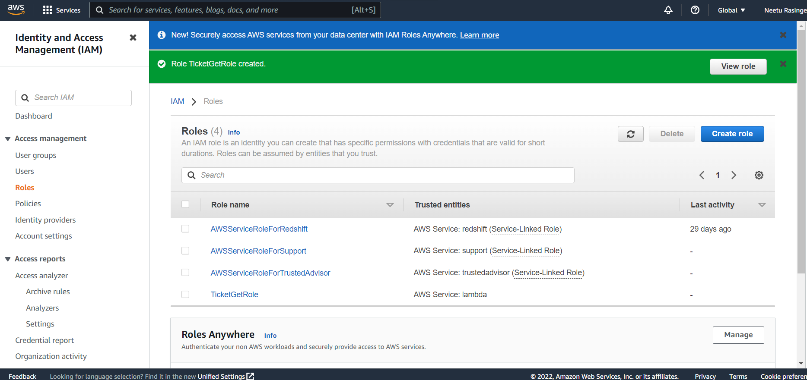

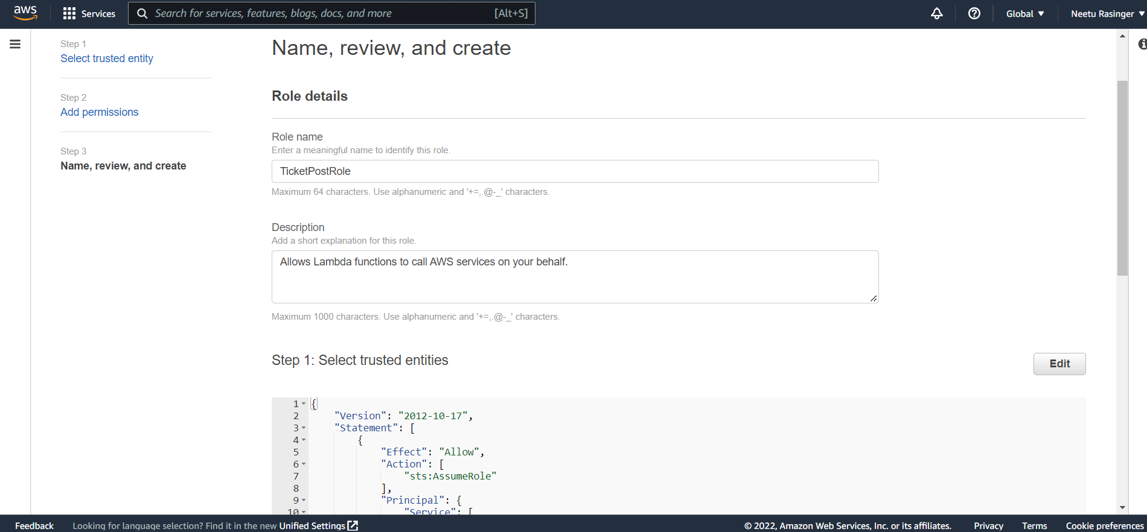

## **Step 4: Creating an environment on AWS Cloud9 with name ‘Arc315’ for the region eu-west-1.**

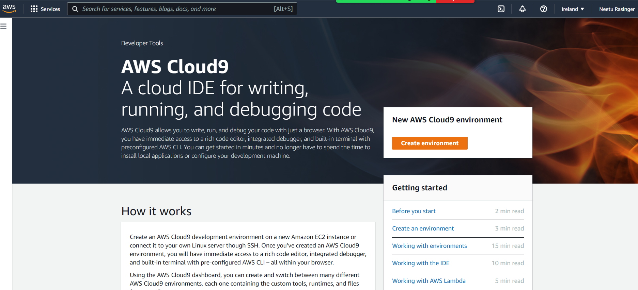

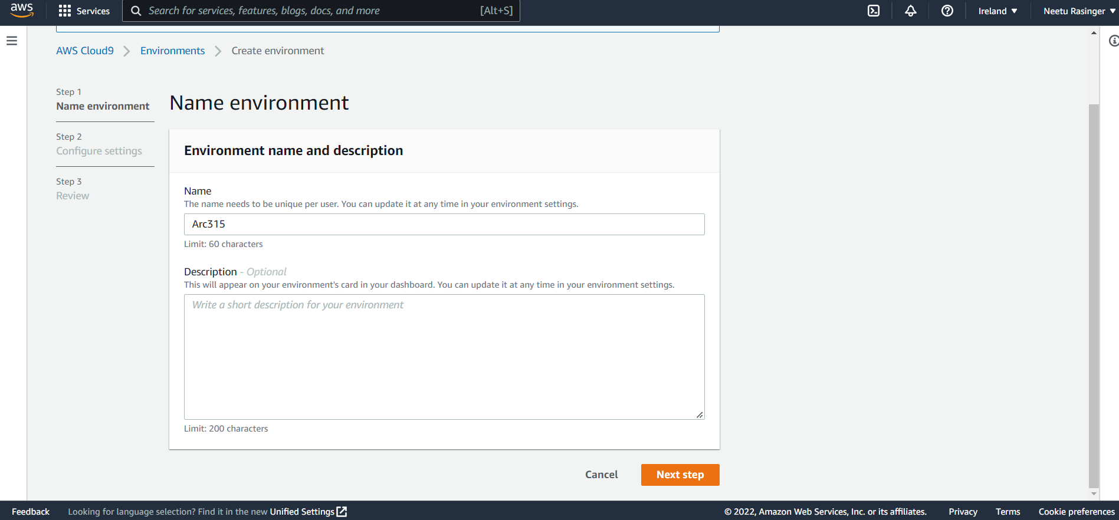

**Selecting the EC2 instance type, we use t2.micro instance**

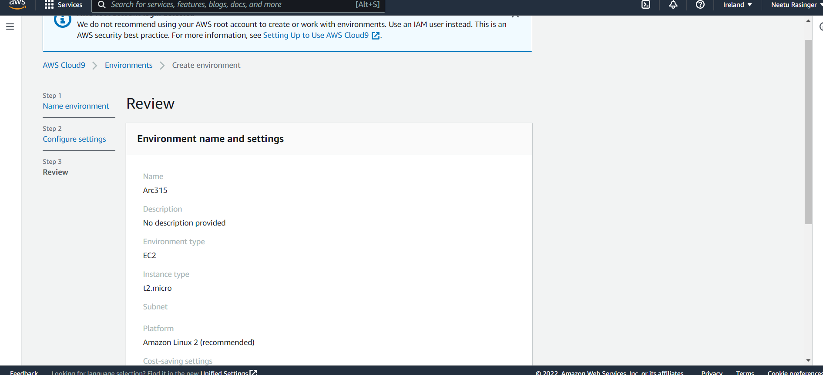

## **Step 5: Installing the node and npm**

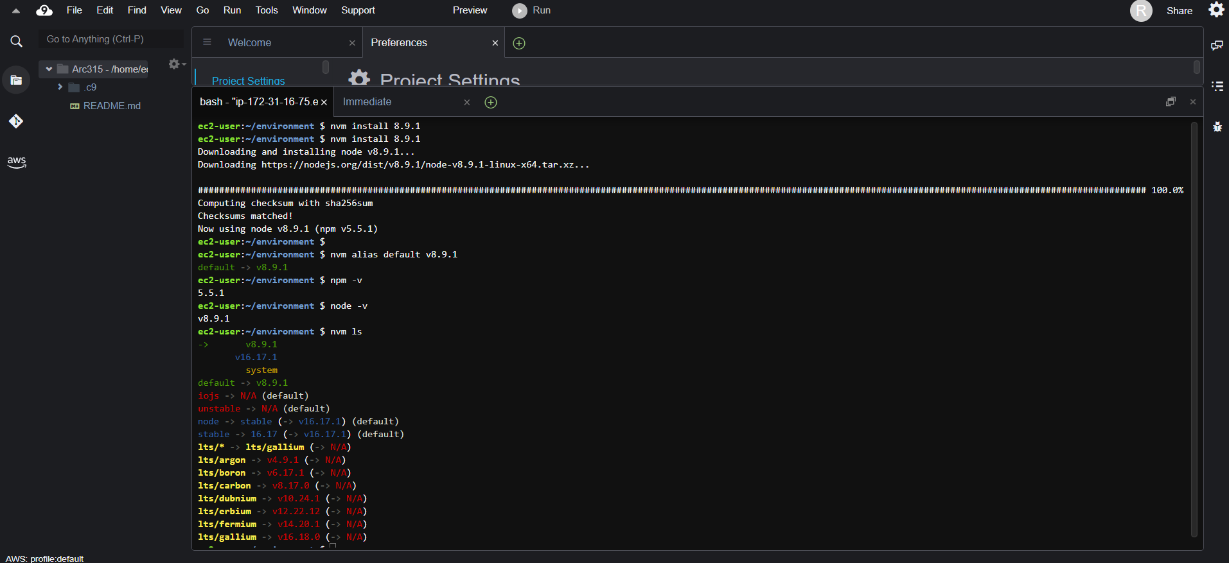

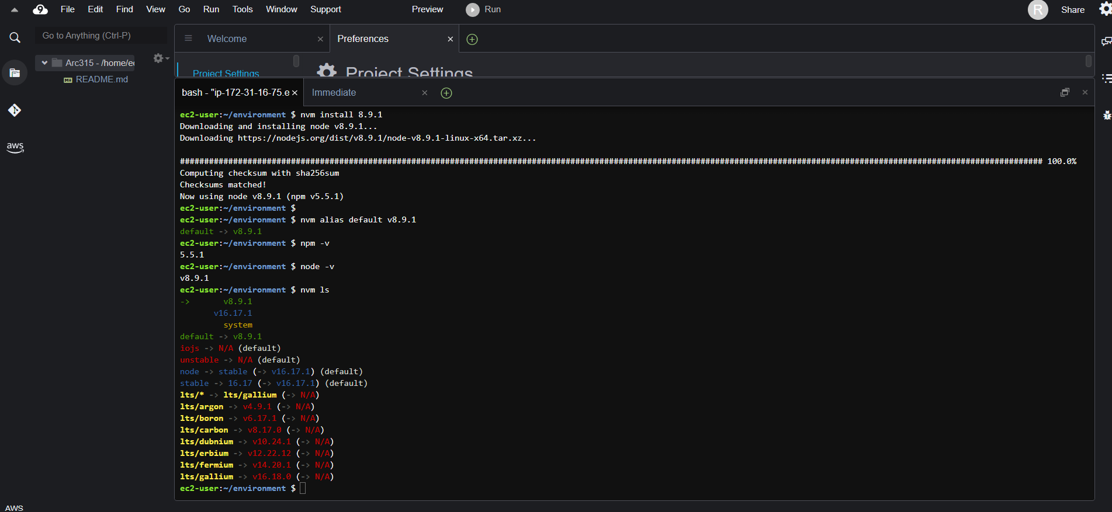

**Step 6: Clone the workshop project in git repository**

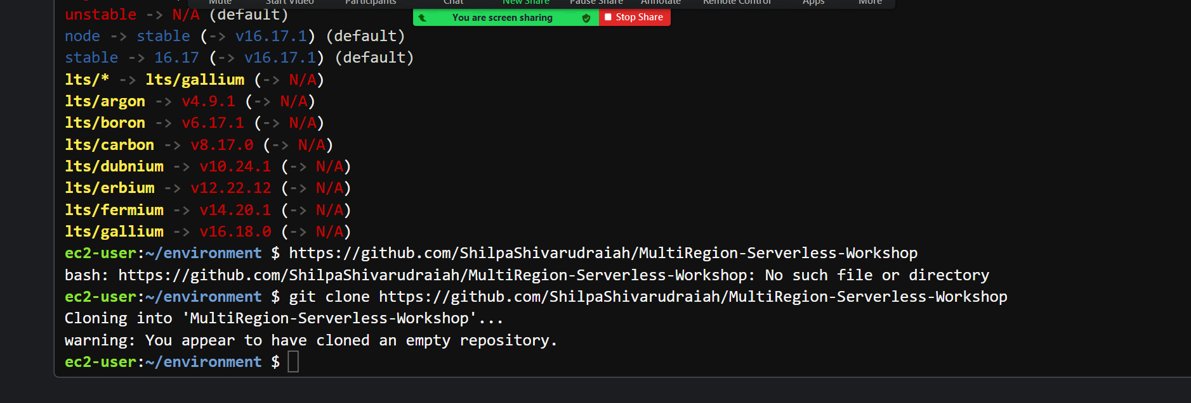

**Building an API Layer**

**Step 7: By creating IAM roles and policies, DynamoDB tables are created for application data.**

* **selected the region as ‘eu-west-1’ for Ireland on the console and opening DynamoDB allows us to create table SXRTickets with Id (String type) as primary key**
* **This table is set up for two regions Ireland and Singapore in a similar way.**

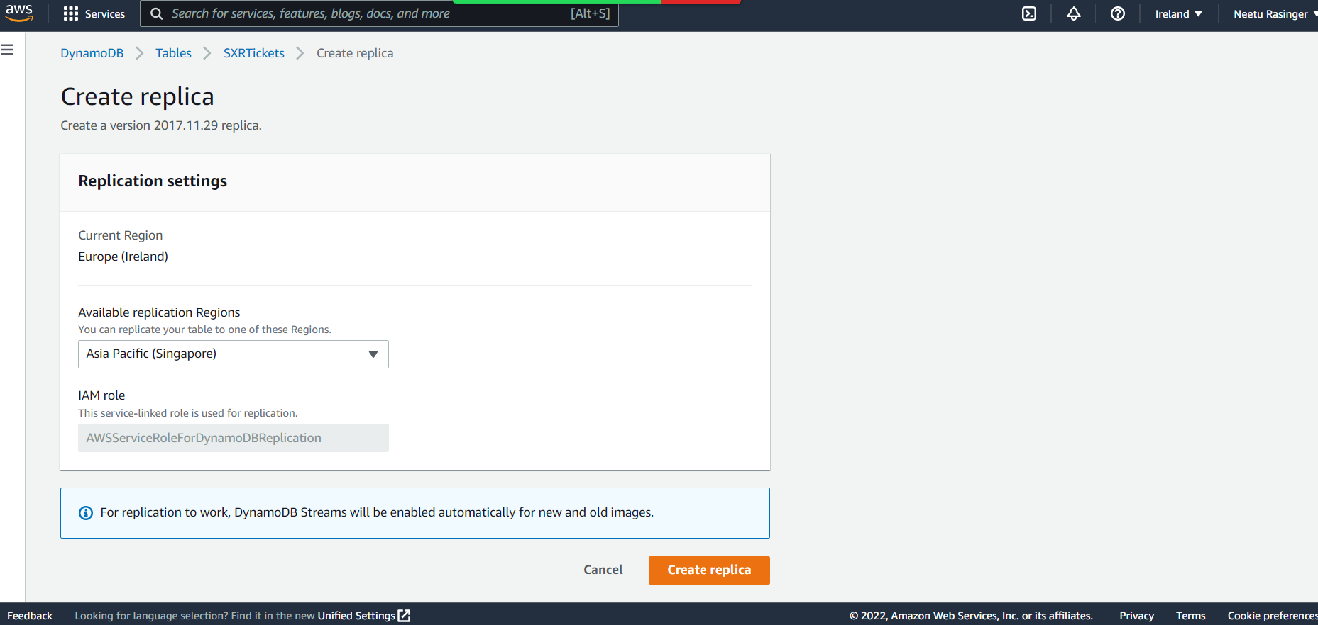

**Step 8: The Environment variable ‘TABLE_NAME’ is updated to ‘SXRTickets1’ as required.**

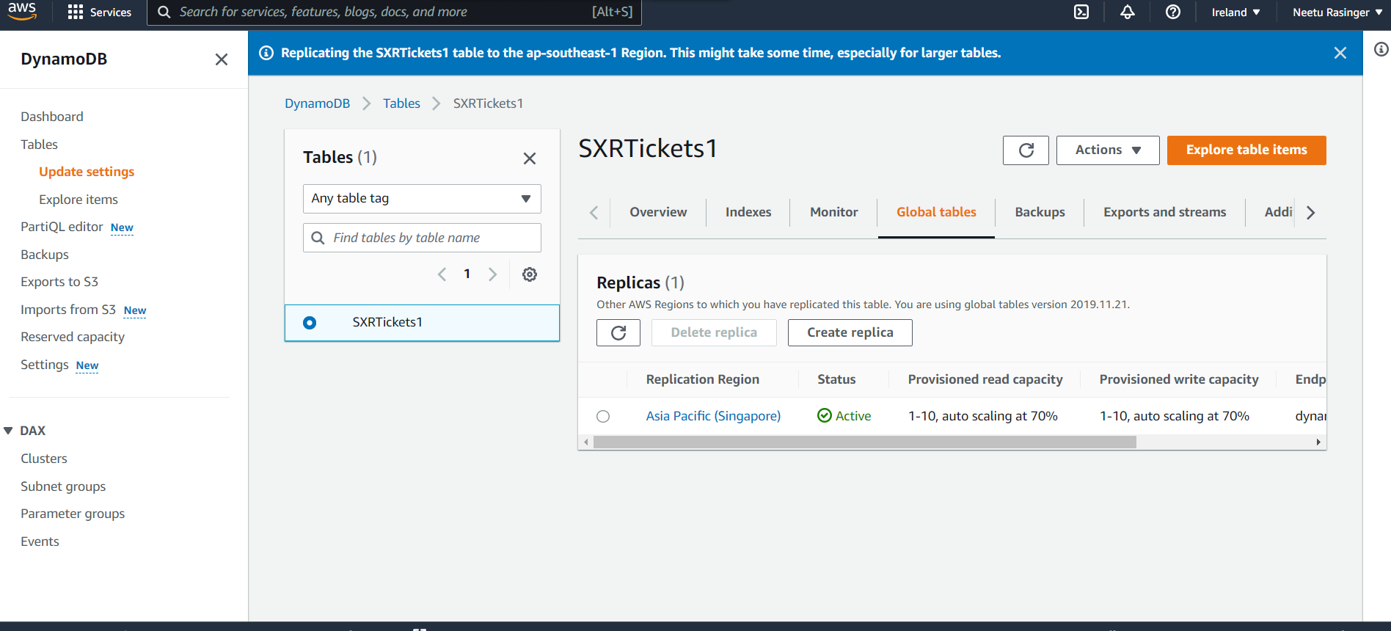

**Step 9: Ensuring that Lambda functions are created for TicketGetFunction and TicketPostFunction for both Ireland and Singapore region.**

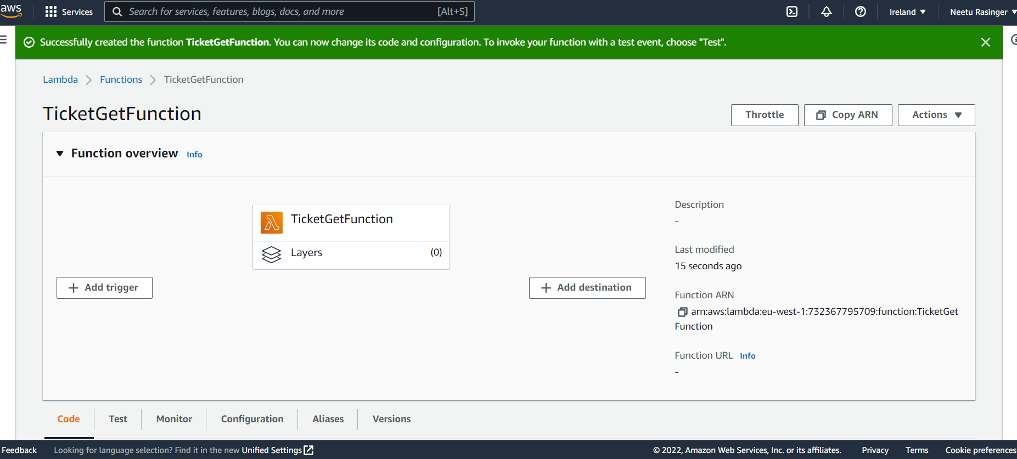

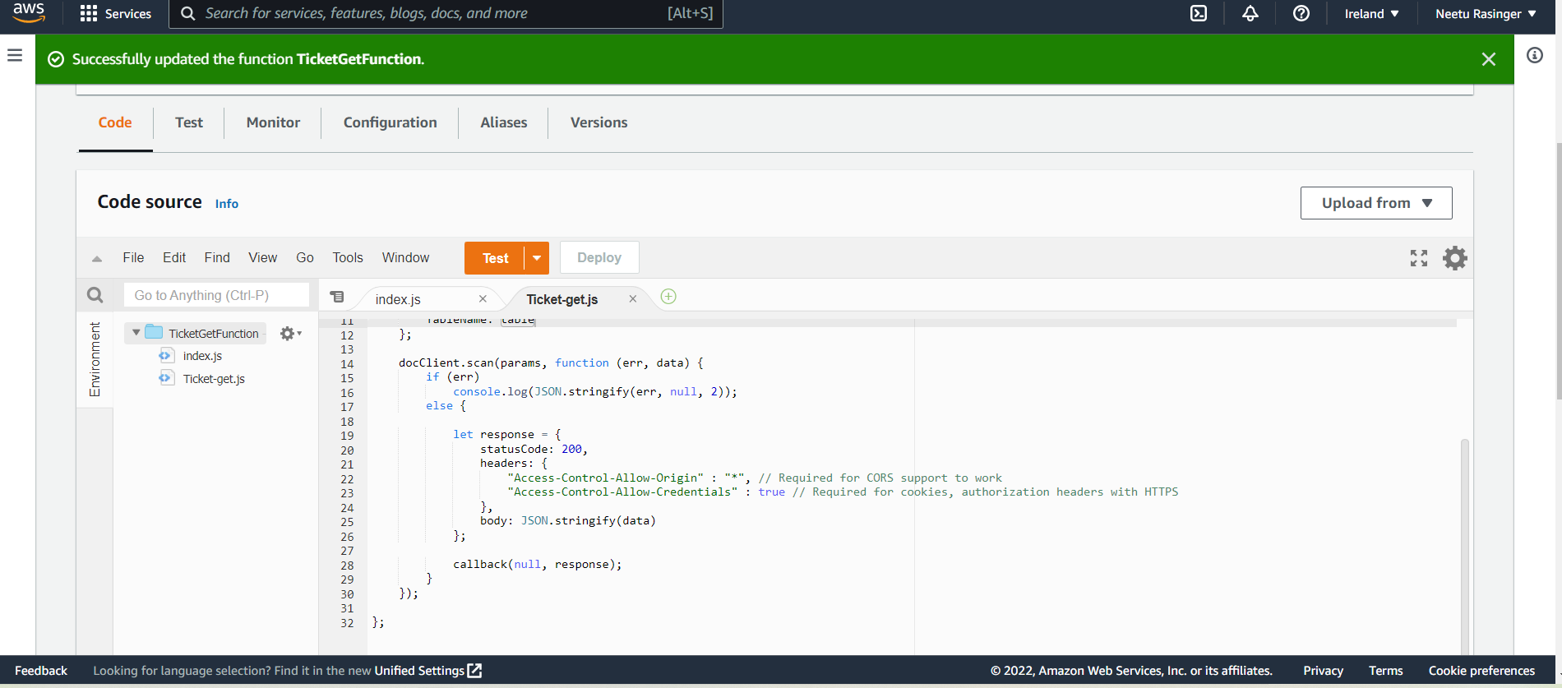

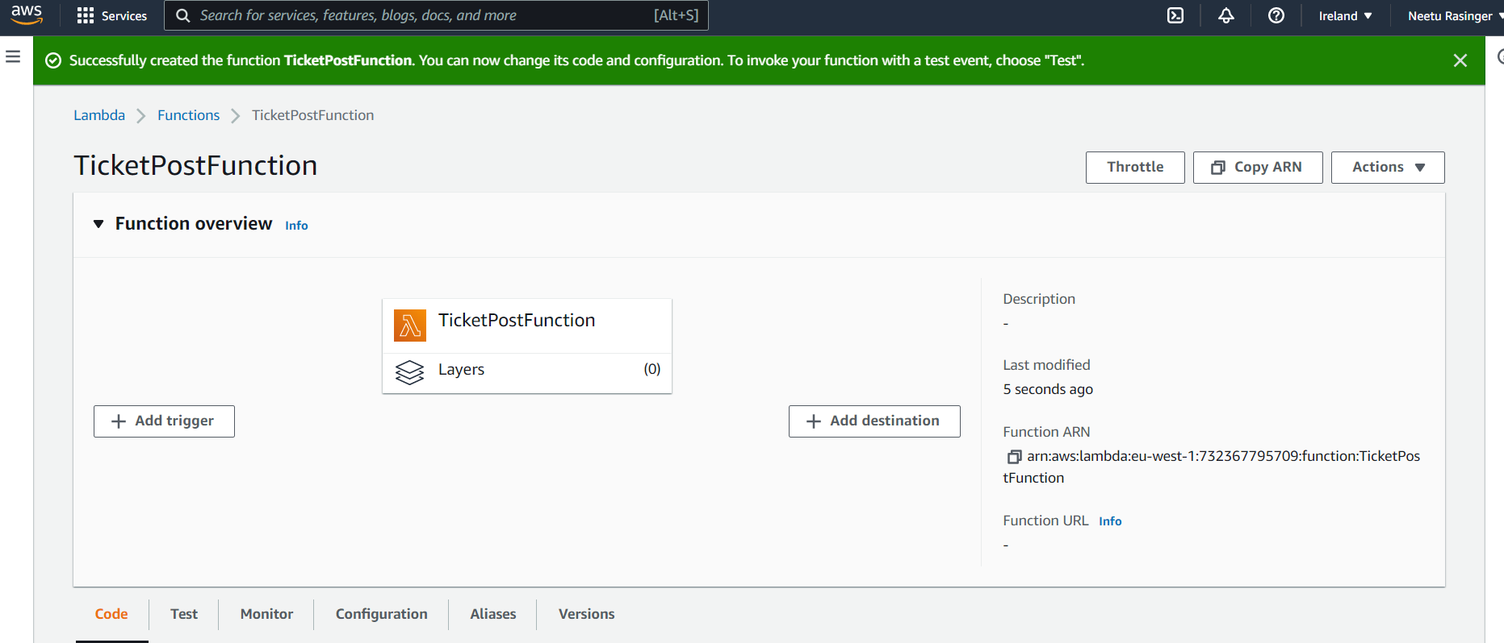

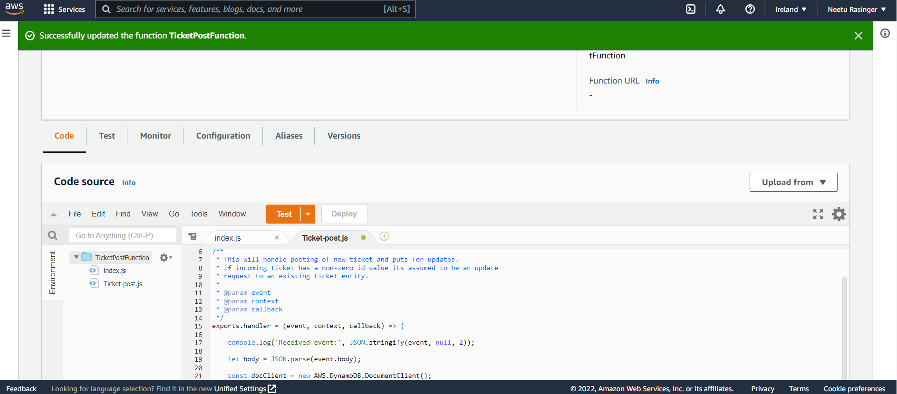

**Step 10: Creating the three lambda functions by navigating to the lambda function in the console and clicking on the creating function. Also ensuring that we are in the correct region. Three functions SXRHealthCheckFunction, TicketGetFunction and TicketPostFunction were created.**

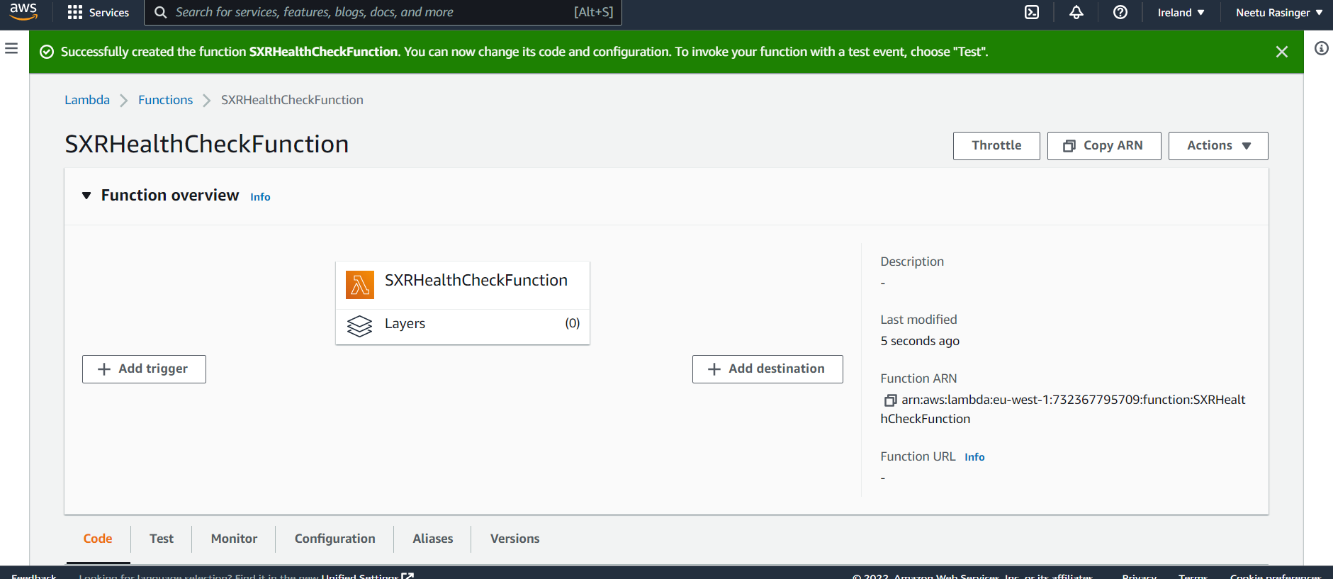

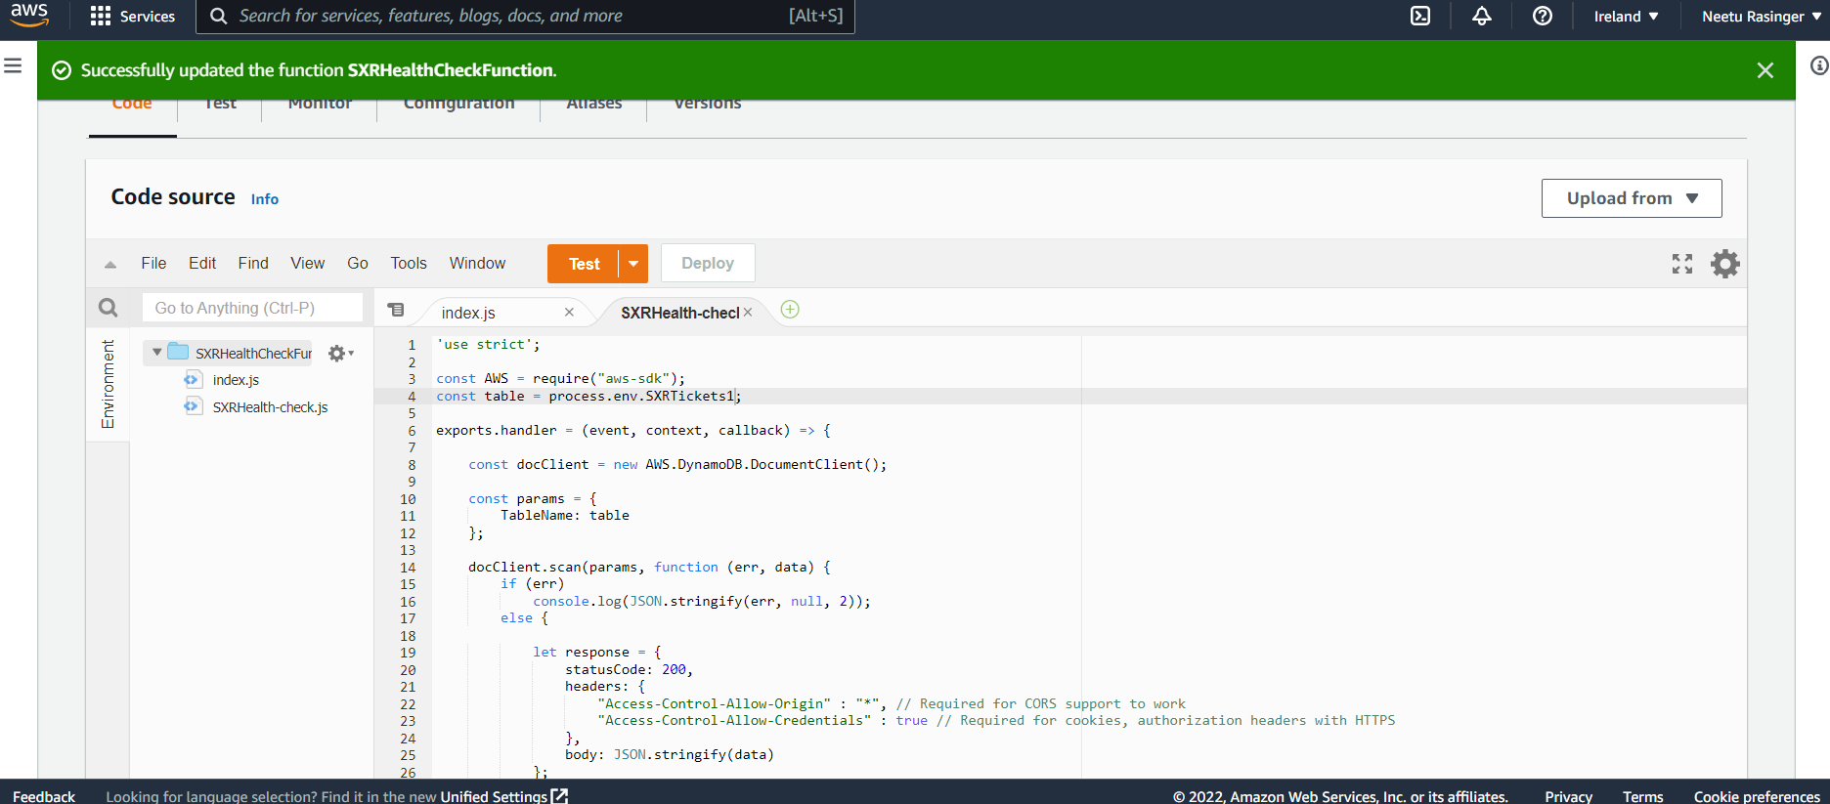

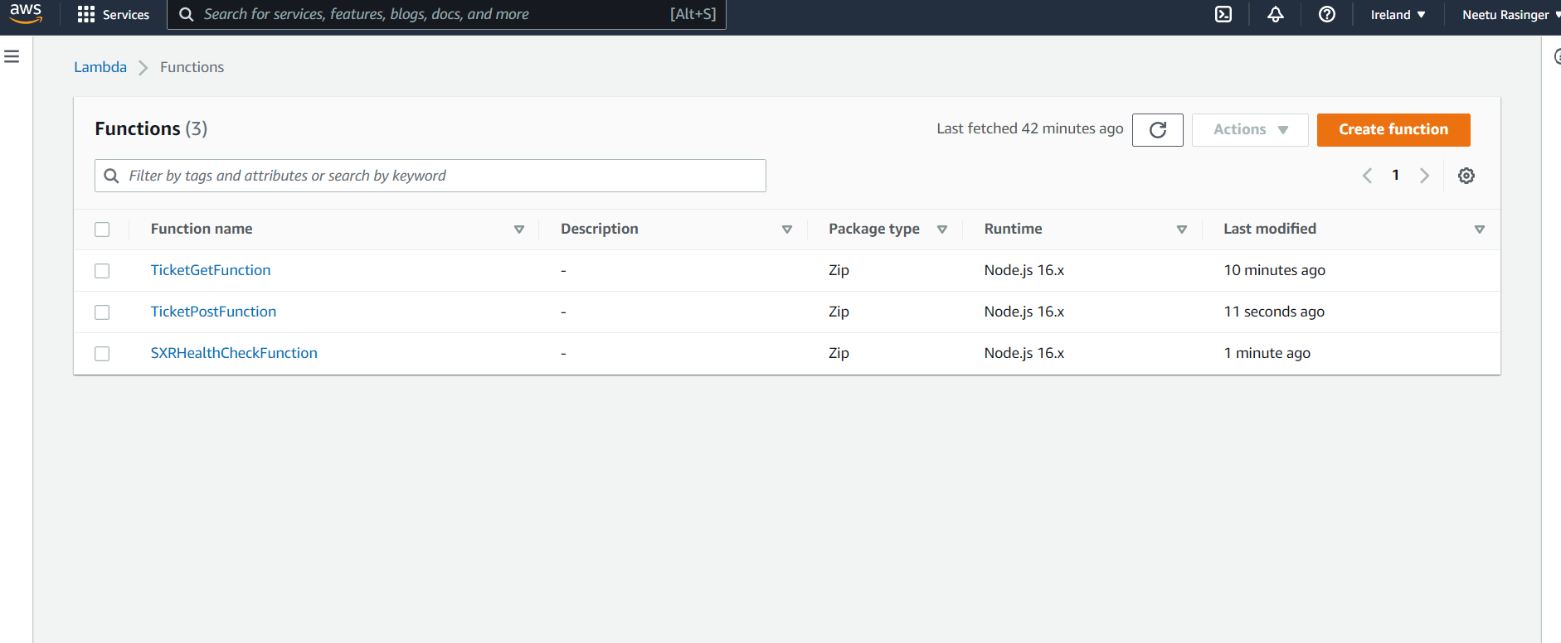

**Step 11: Creating the API Gateway Endpoint : Navigating to the API Gateway, by creating a new API with name ‘*wild-rydes-api*’for regional endpoint.**

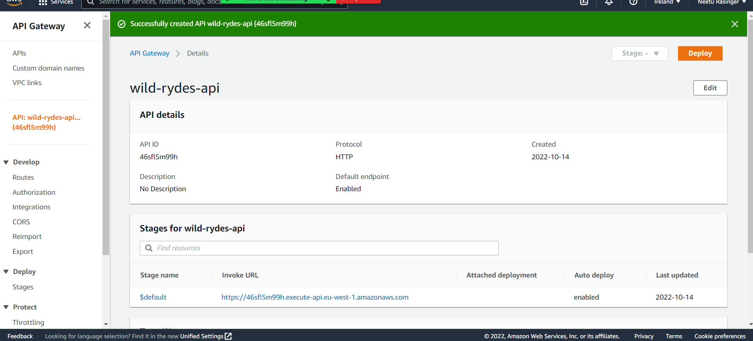

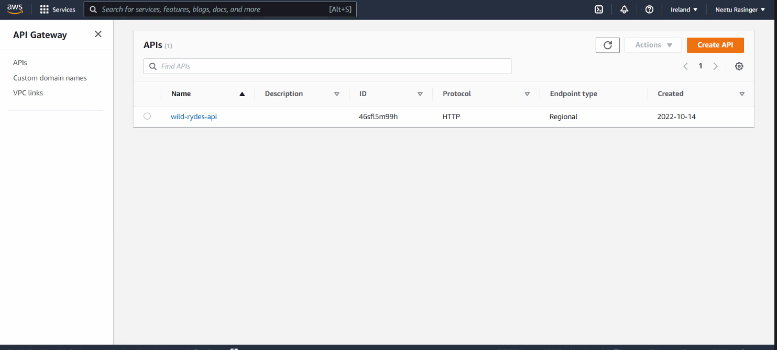

**Step 12: After clicking on the *Actions* drop-down, select the Create Resource option with the resource named as “ticket” and then select the *Enable API Gateway CORS* option and then click on Create Resource.**

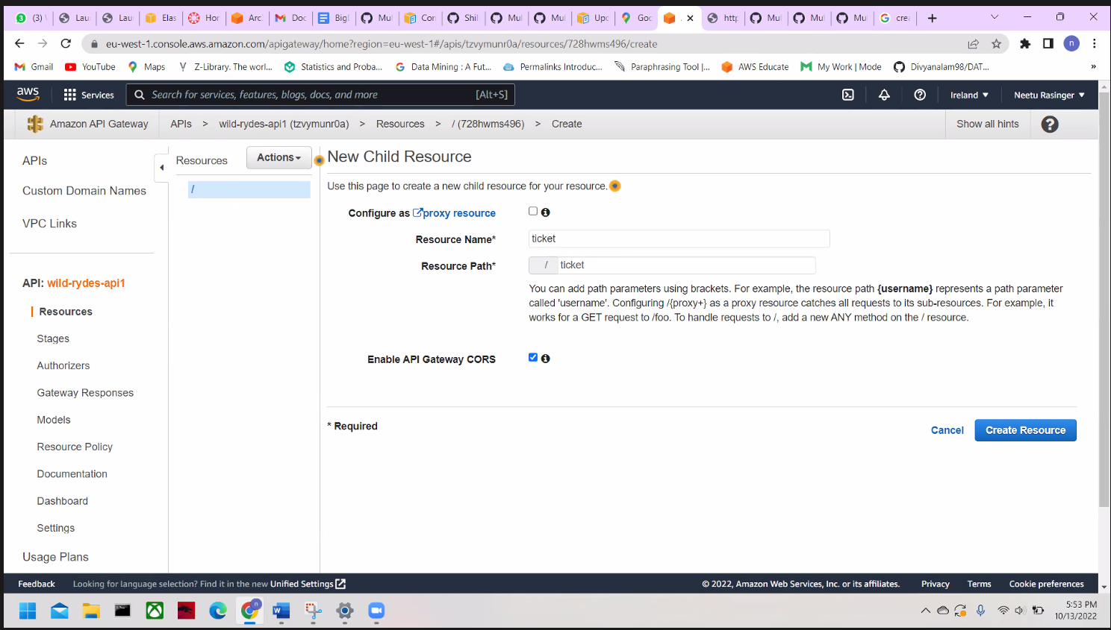

**Repeated this same process, by creating the resource name “health” and also ensuring that resource is at the same level as the ticket.**

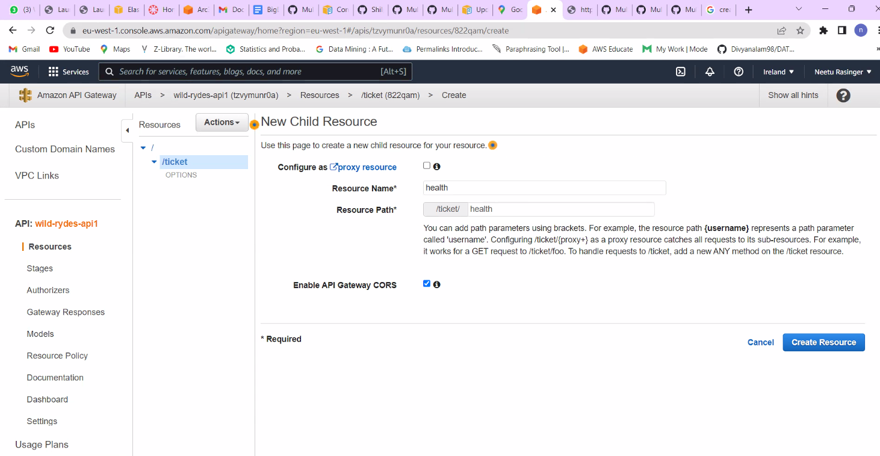

**Step 13: By selecting the lambda function we enabled *Use Lambda Proxy Integration* and choose ‘eu-west-1’ as the Lambda Region and then start typing in the Lambda Function box and selected TicketGetFunction and Saved it**

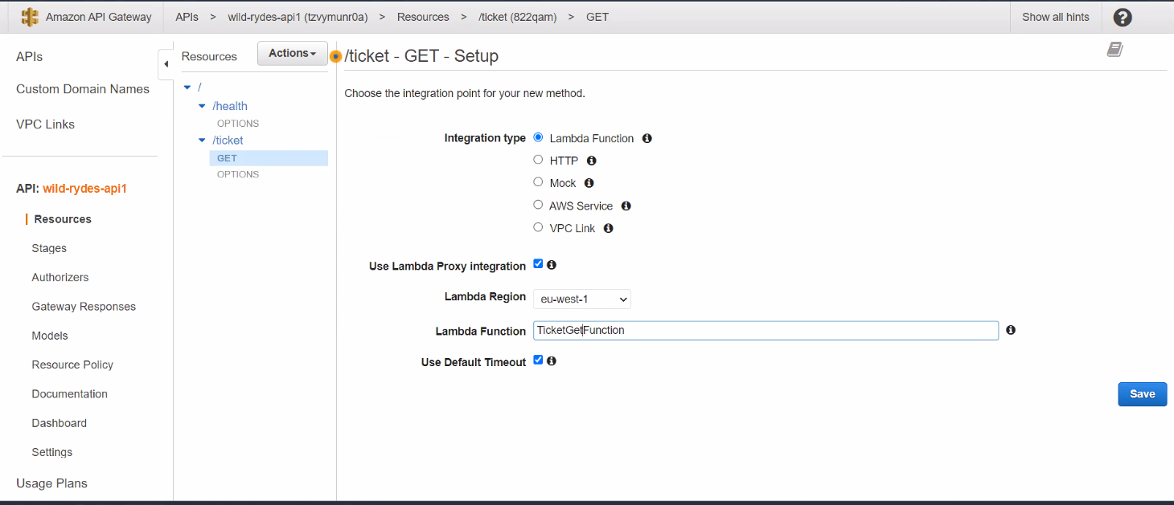

**Step 14: Enable Cross-Region by selecting the ticket under *resources* and from the *Actions* drop-down, we Enabled CORS.**

**After clicking on the Enable CORS, we replaced the existent CORS Header button.**

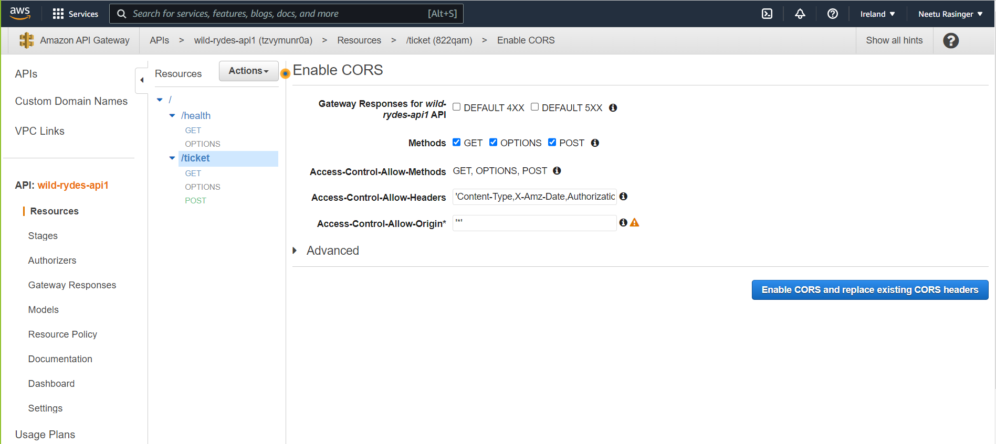

**This same process was repeated for “health” resource as well.**

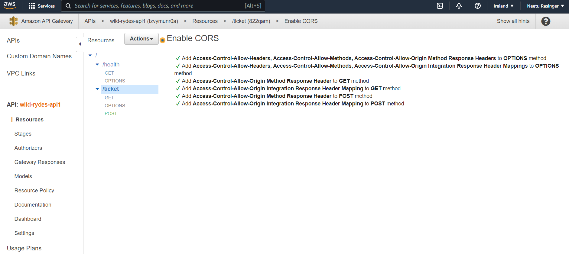

**Step 15: Next, we deploy the API by clicking on the Actions pull-down and selecting Deploy API.**

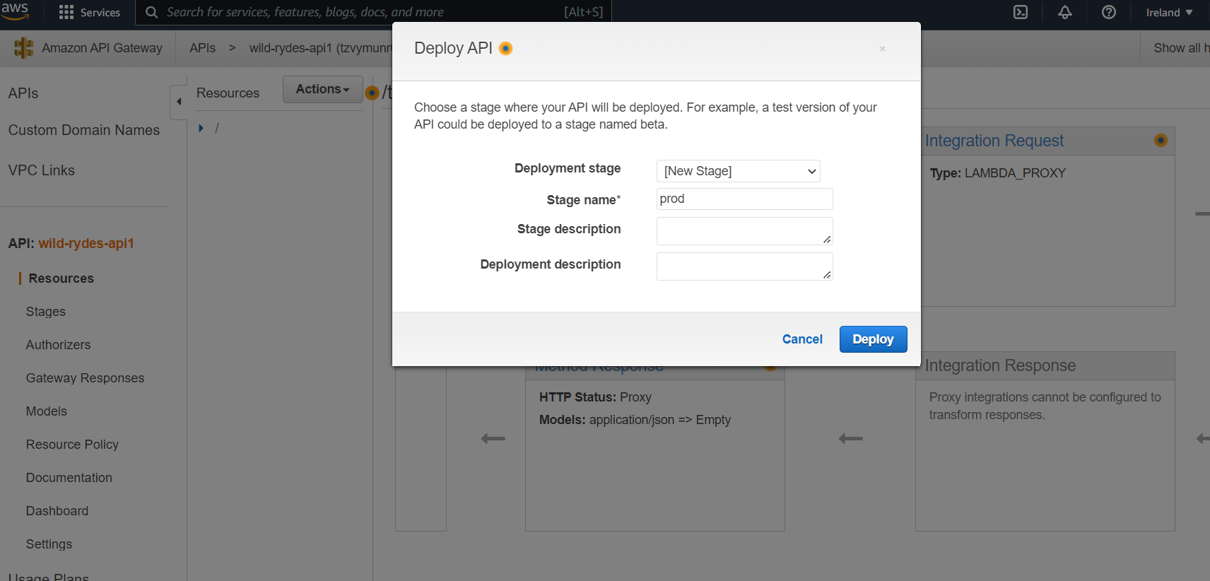

**Step 16: Testing the API Gateway Endpoints. We selected the Stages from the left menu under the API Endpoint and expanded "prod", and selected “post” and “get” from the *ticket* resource (API URL is provided below).**

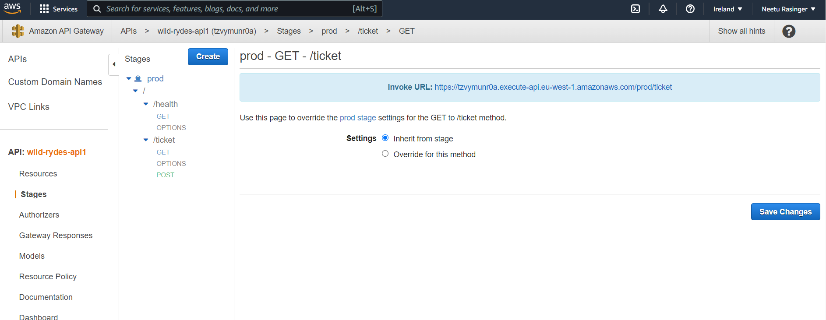

[**https://tzvymunr0a.execute-api.eu-west-1.amazonaws.com/prod/ticket**](https://tzvymunr0a.execute-api.eu-west-1.amazonaws.com/prod/ticket) **- Api end pint url**

**Step 17: Similar processes were followed for the Singapore region i.e. creating the three lambda function and creating the API gateway endpoint.**

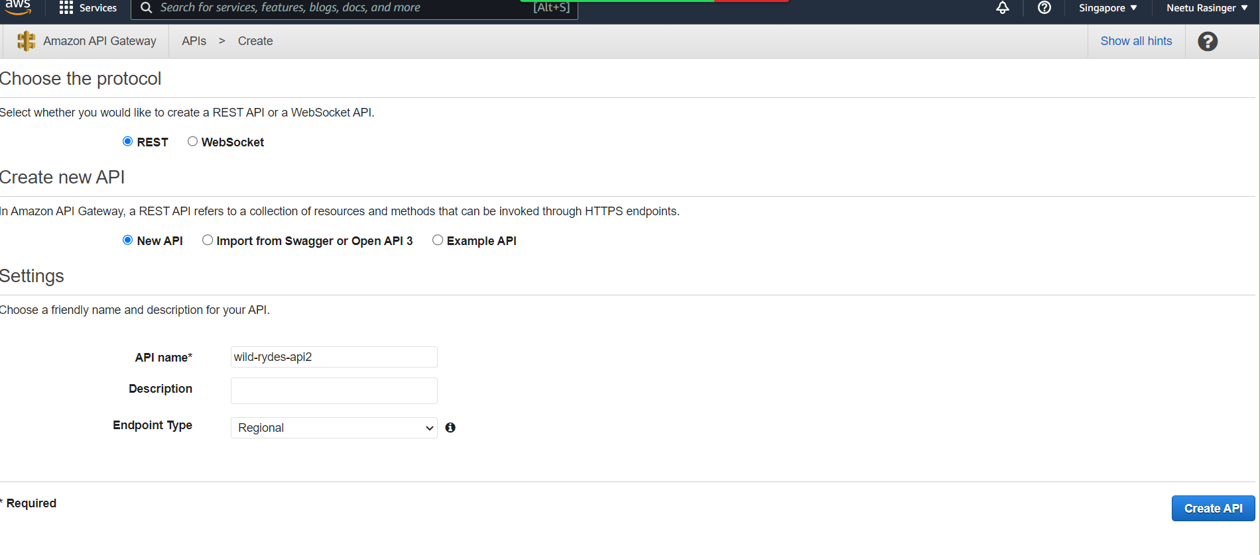

**Building the UI Layer**

**Step 18: After successfully creating the API layer the functionality can be deployed for the users to access.It is primarily deployed in the Ireland region. Below screenshot shows the statements to set up Cognito so that the application can authenticate and gain permissions to call the API.**

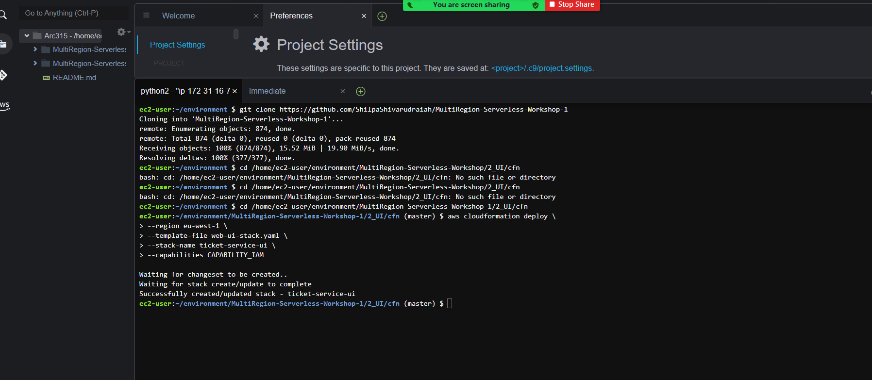

**Step 19: Once the above code is successfully executed. We also validated the outputs on CloudFormation service to view the stack created as well as to obtain the CognitoPoolID and the BucketName.**

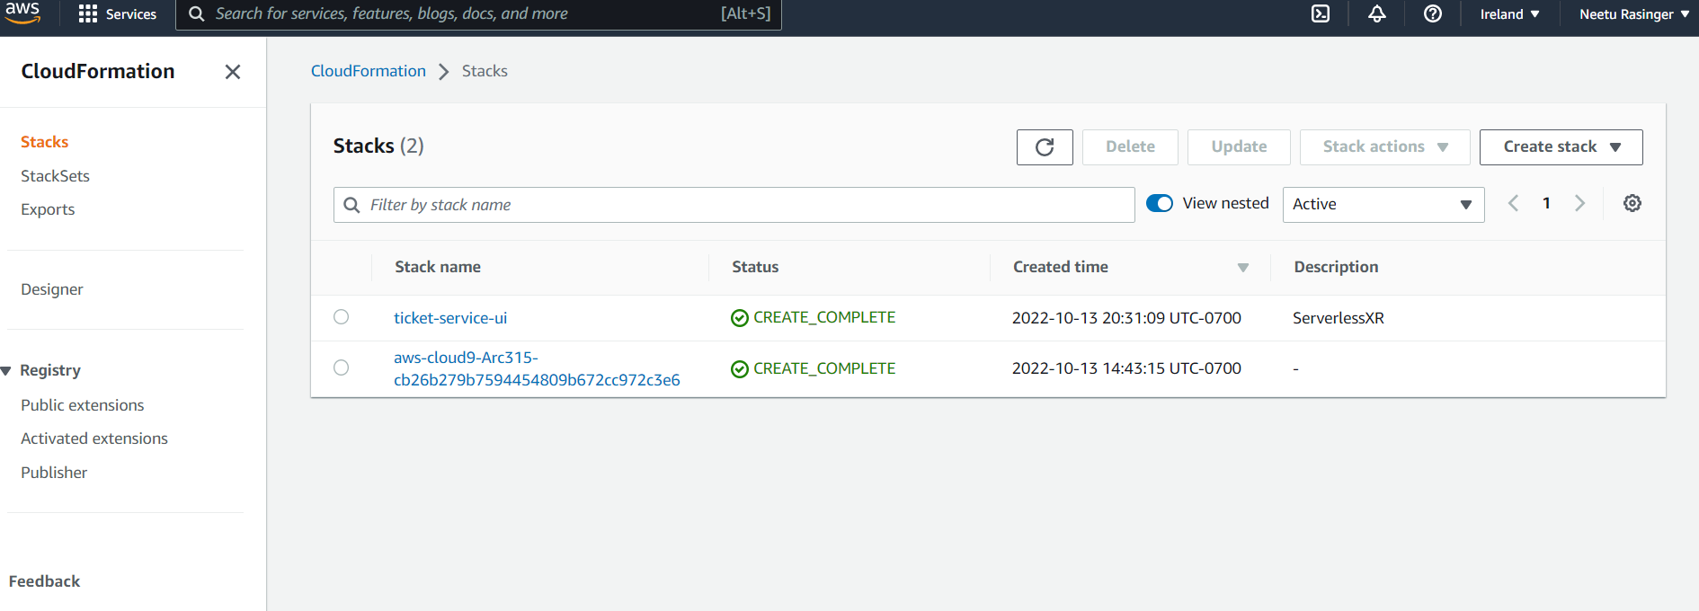

**Step 20: Using the Key “BucketName” cloudfront distribution is created.**

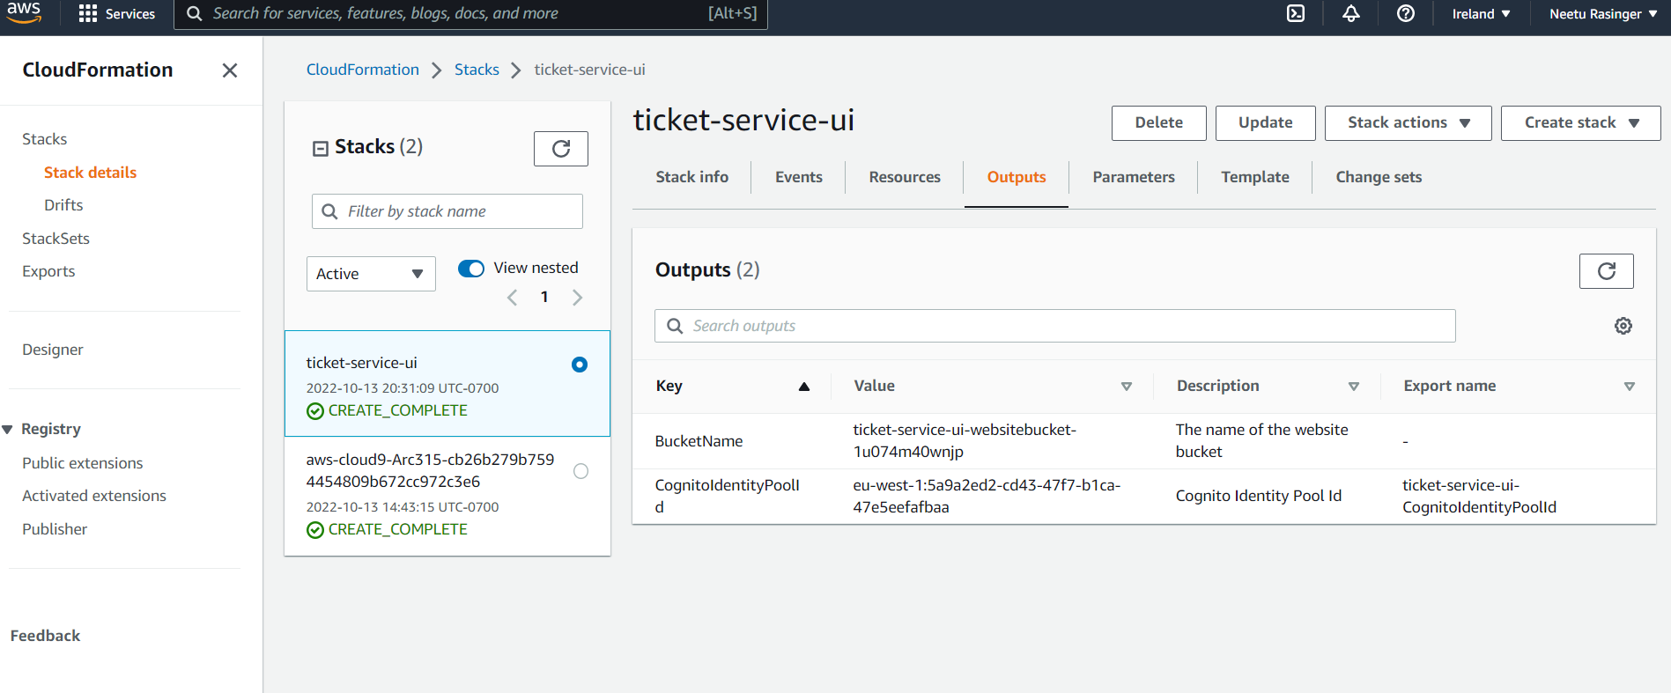

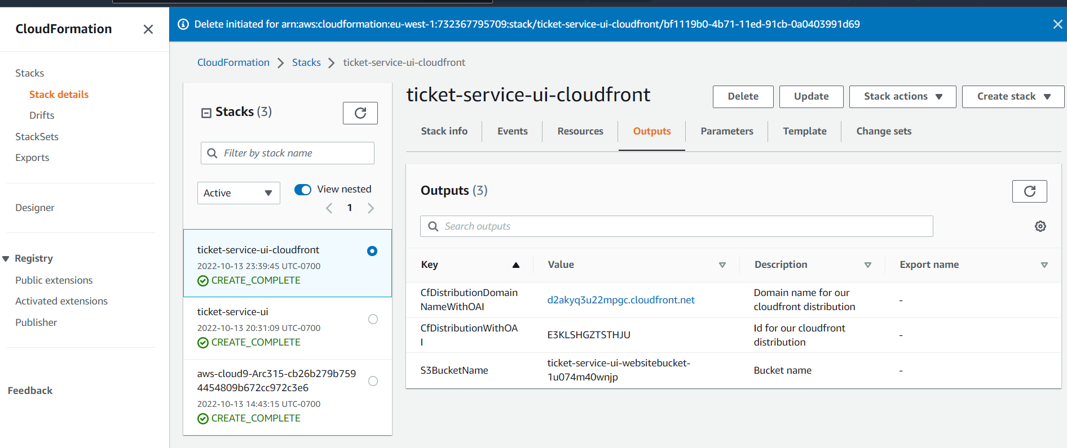

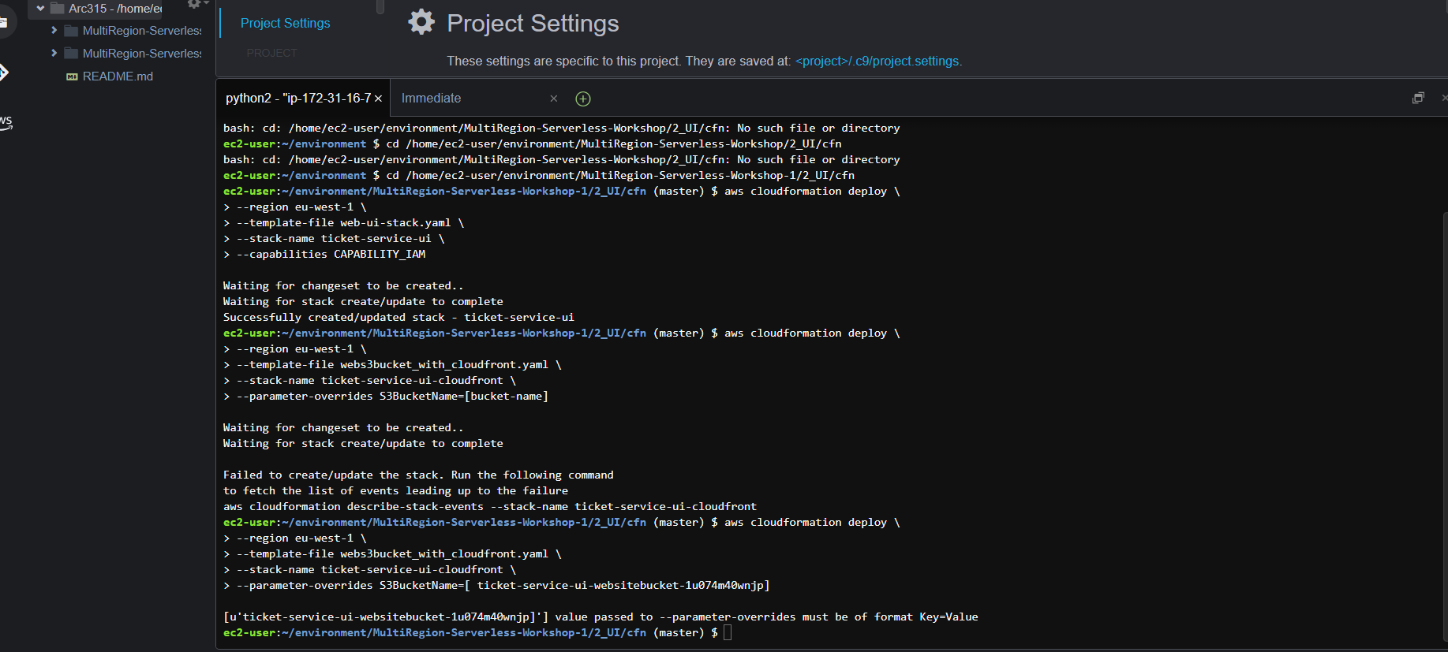

**Step 21: Configuring the Cognito Identity Pool with Facebook as identity provider.**

* **From the Facebook developer account, a new application is created to allow us to choose from multiple platforms such as android, website, IOS etc. We selected a ‘Website’ for Application development.**
* **This step generates our Cloudfront URL and 15-digit App ID. This is used for updating the configurations for the Cognito Identity pool SXRIDENTITYPOOL.**

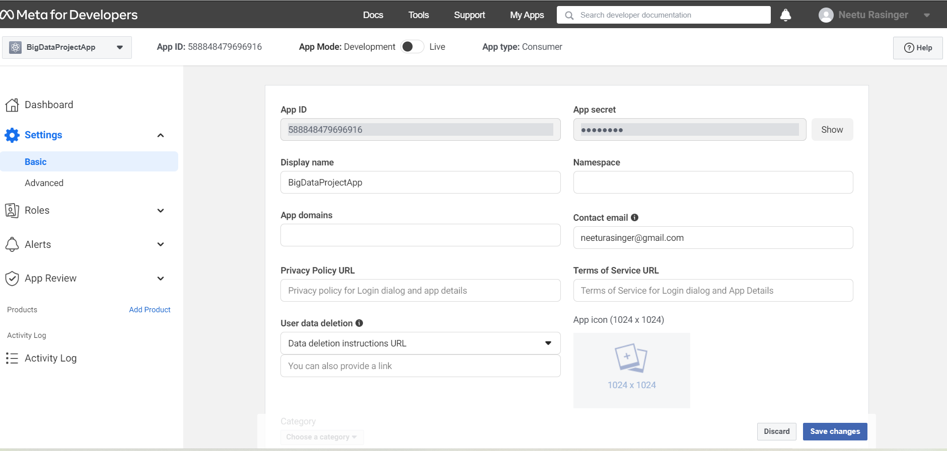

**Step 22: Unlocking the Facebook App Id by clicking on the Identity Pool Id and navigating to the authentication provider section.**

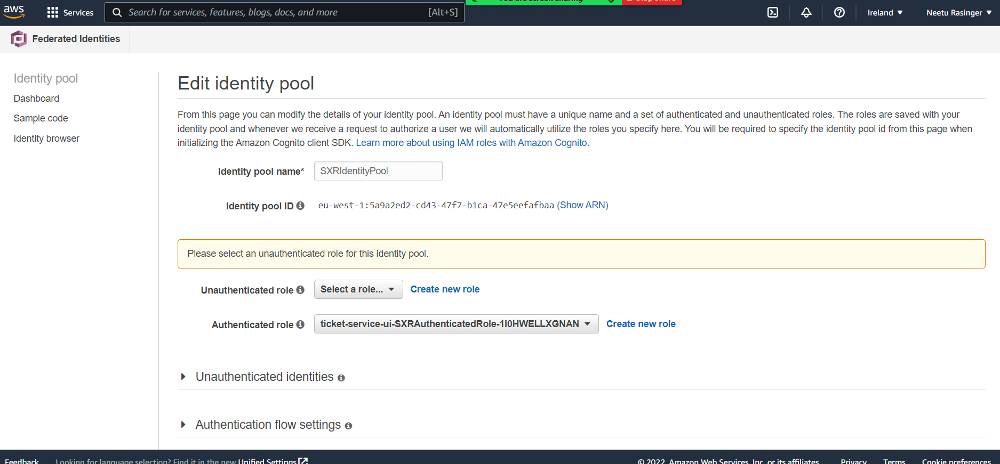

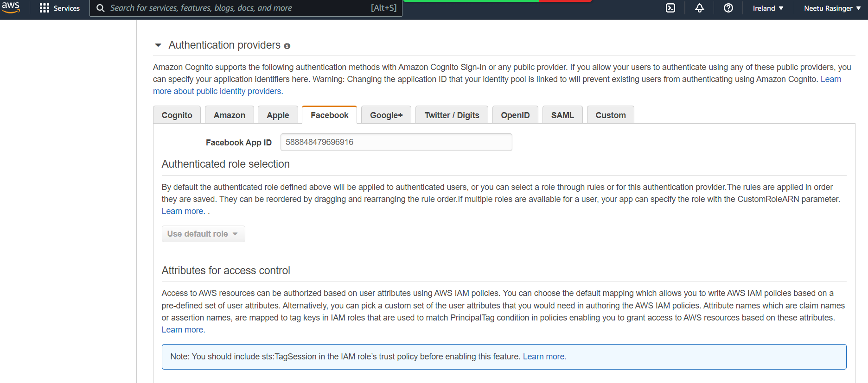

**Step 23: Build your AngularJS project by:**

* **First going to the root folder of the ui project, cd /home/ec2-user/environment/MultiRegion-Serverless-Workshop/2_UI**
* **Then installing the npm to install project dependencies**
* **Lastly, built the app by running “npm run build**

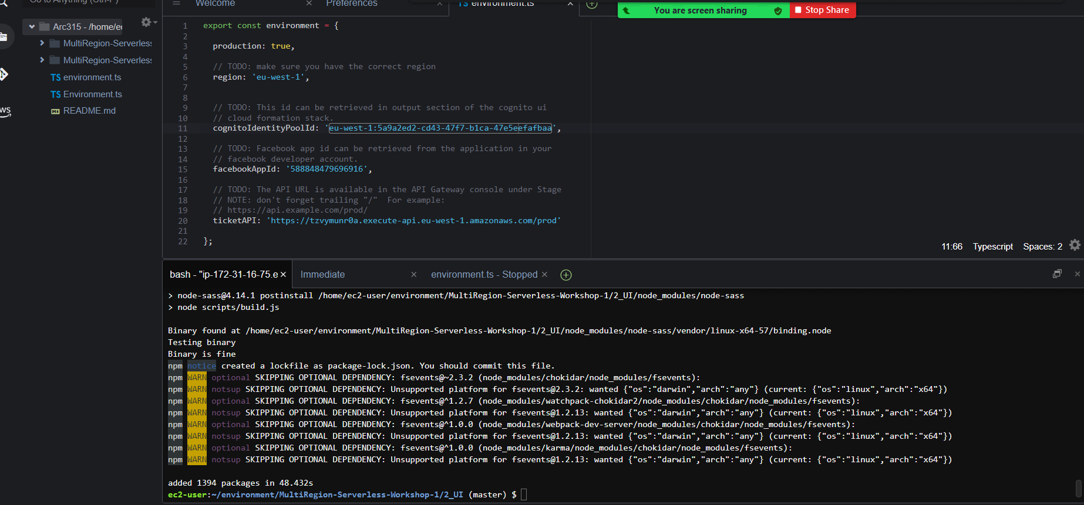

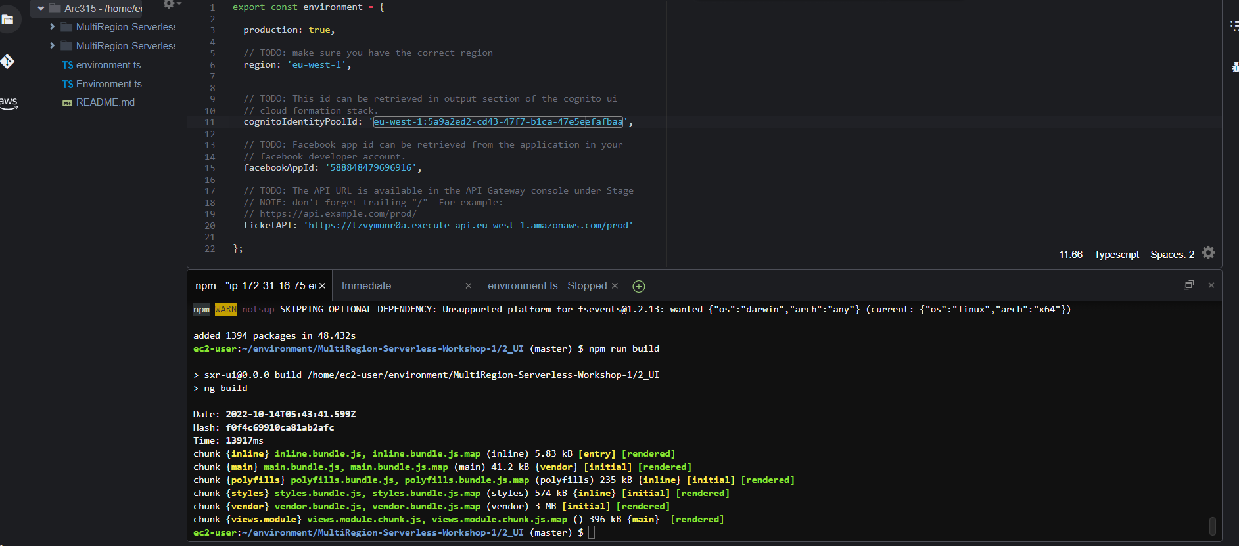

**Step 24: Uploading the application. For doing this, we navigated back to the Facebook App setting and updated the "App Domains" and "Privacy Policy URL" with the Cloudfront URL. Toggle on the "Off" button at the top right corner to make the App public.**

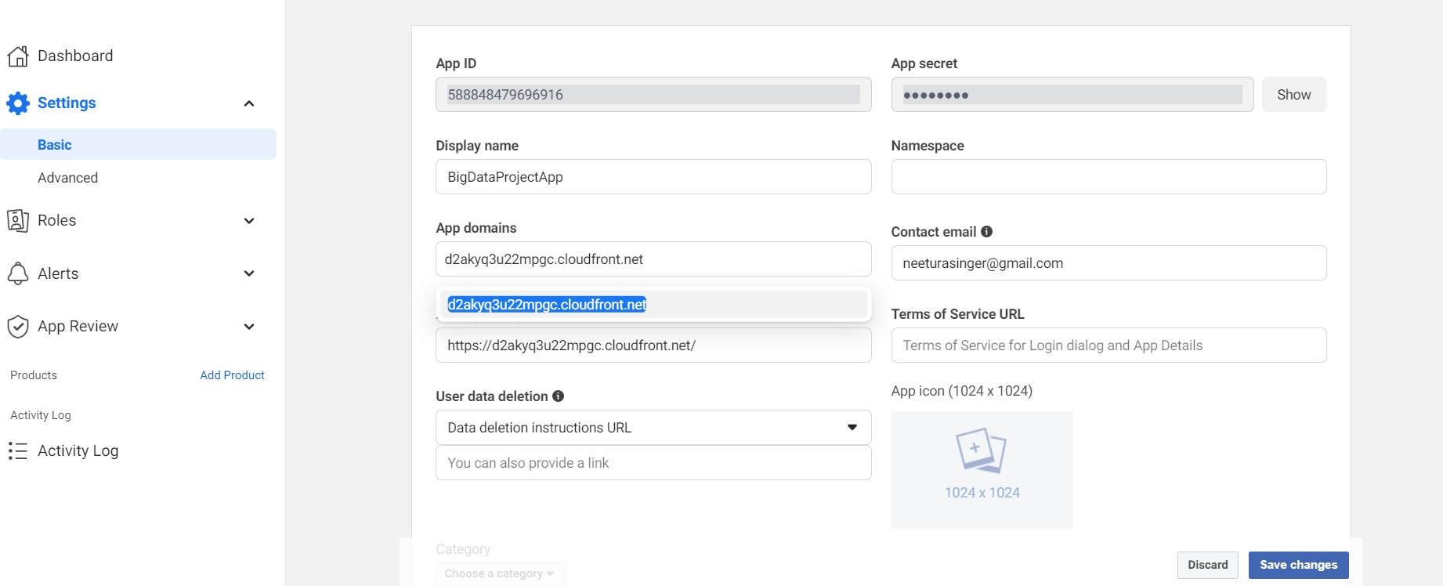

**Step 25: To cross verify we navigated to the Cloudfront URL. As per the manual, we should see simple ticketing application as shown below**

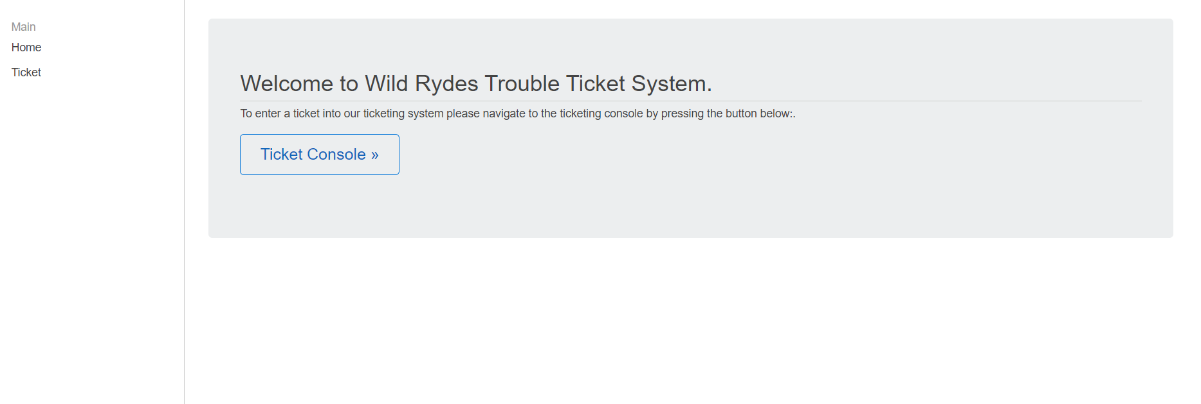

**Configure Active-Active Route53**

**Step 26: Configured Custom Domains and ACM in API Gateway.**

* **After the domain is registered, through AWS Certificate Manager, an SSL certificate is configured to the domain name with API Gateway.**
* **This is done for the primary region first, ie, Ireland.**

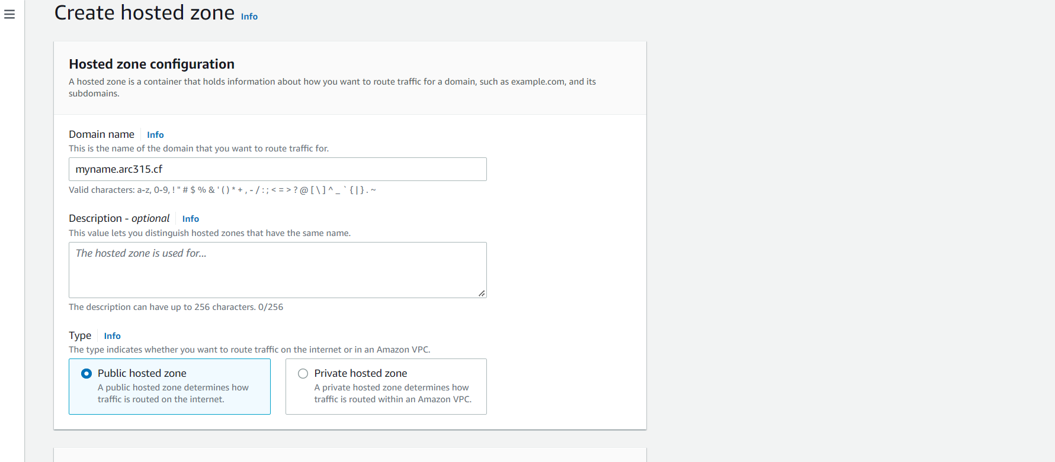

**Configured certificate in Certificate Manager in each region**

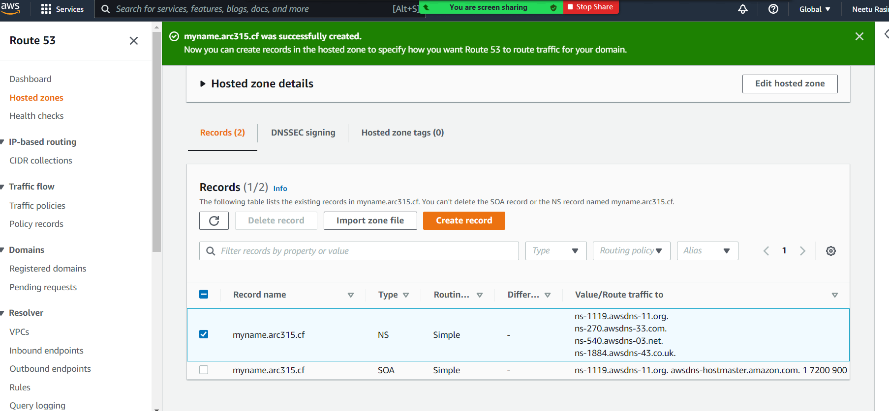

**Step 27: Requesting the Provision certificate by selecting on DNS validations and reviewing the same to confirm if both domains are configured.**

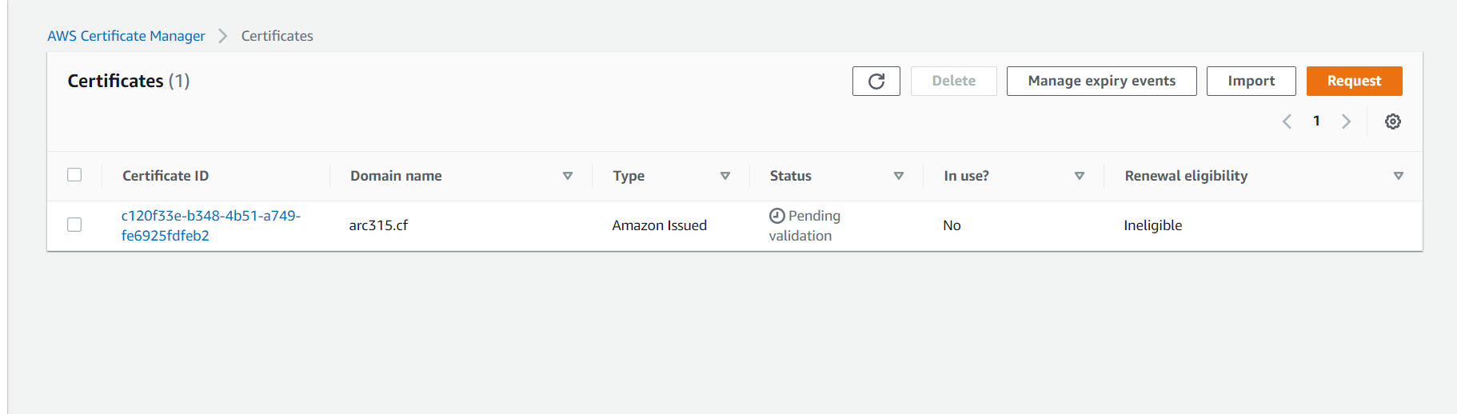

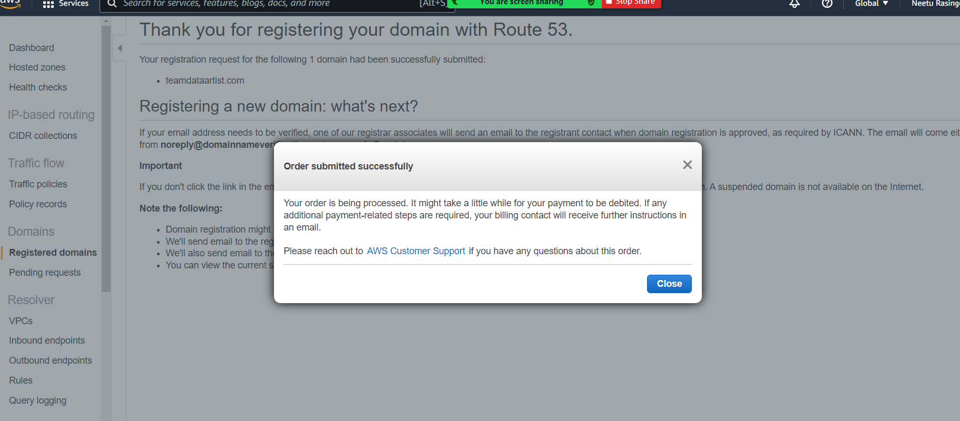

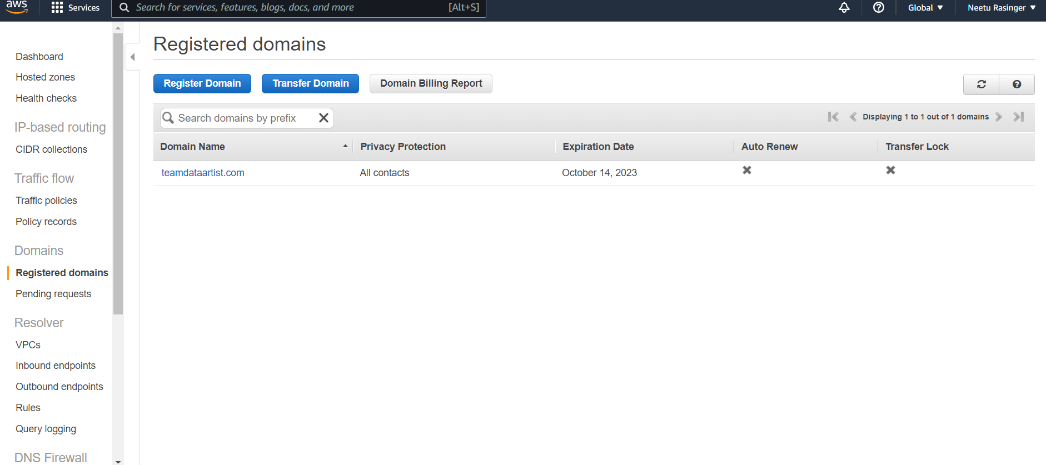

**Step 28: Requesting a public certificate by clicking on provision certificates.**

* **We configured two domain name that was registered**
* **We added two domain names to make sure we have access by using subdomains by using teamdataartist.com and *.teamdataartist.com**
* **The * acts as a wildcard allowing any subdomain to be covered by the certificate**

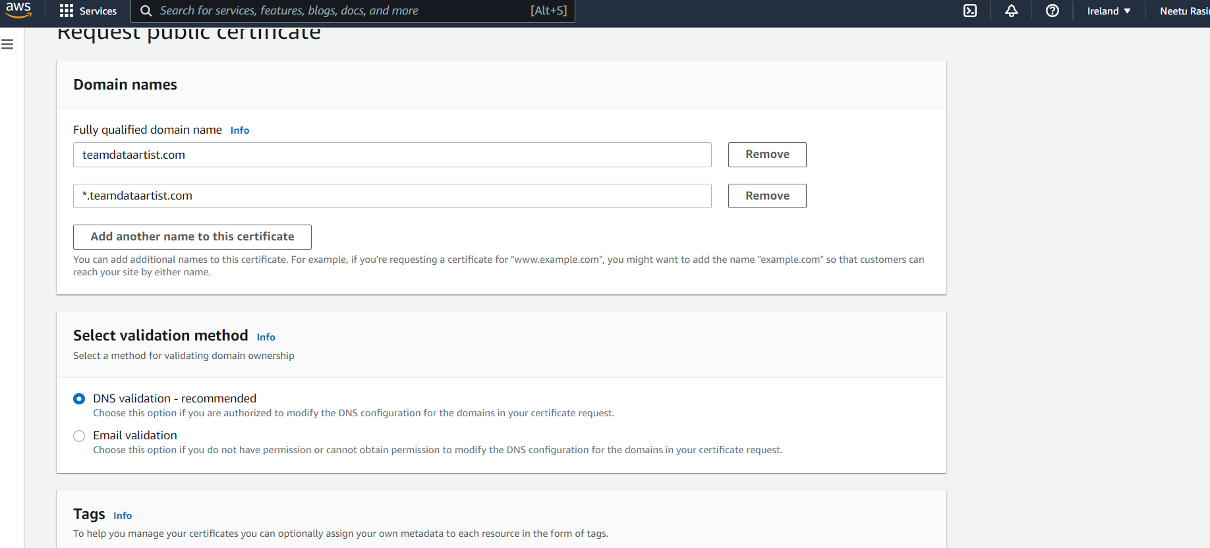

**Step 29: Next we clicked on Review and confirm that both domains are configured and selected confirm and request. Below is the screenshot showing successfully created DNS records.**

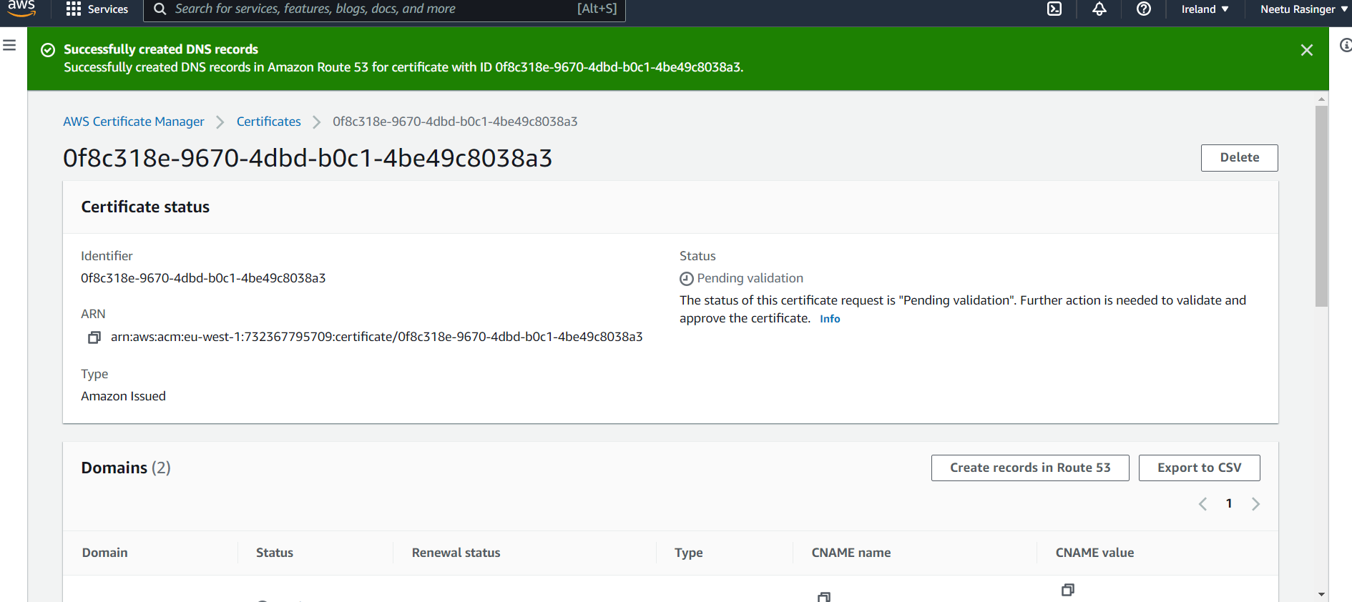

**Step 30: In the Validation screen, we clicked on Create record in Route53. The DNS records (CNAME and Value) were written to your Route53 hosted zone.**

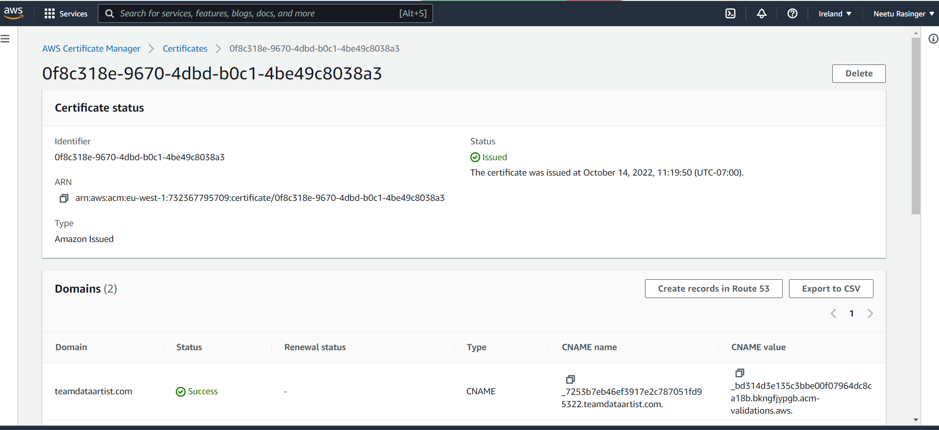

**Step 31: Navigated to the API Gateway Service and then configured the domain name api.teamdataartist.come and selected the endpoint as “regional”.**

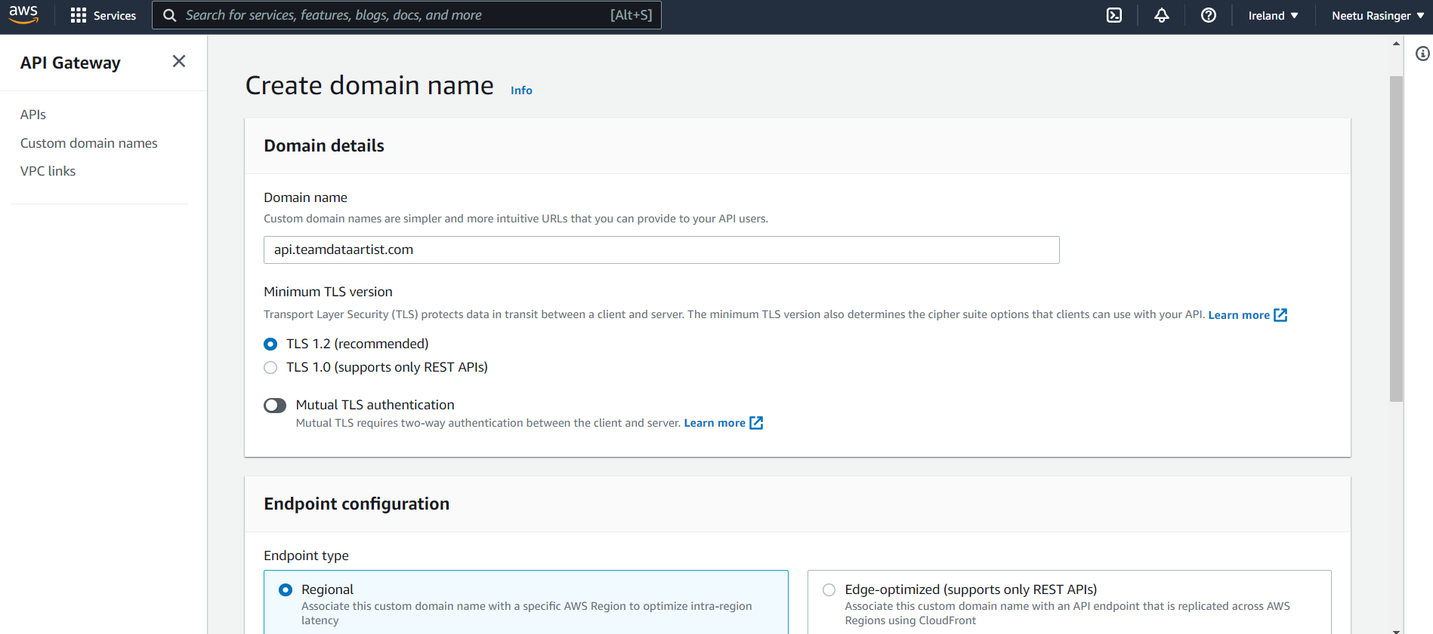

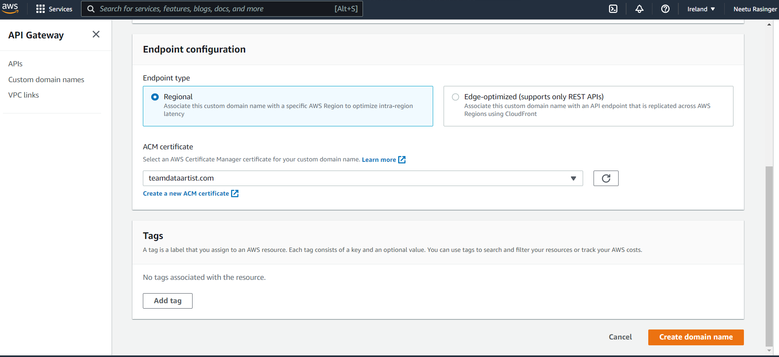

**Below is the screenshot showing the domain name “api.teamdataartist.com” successfully created.**

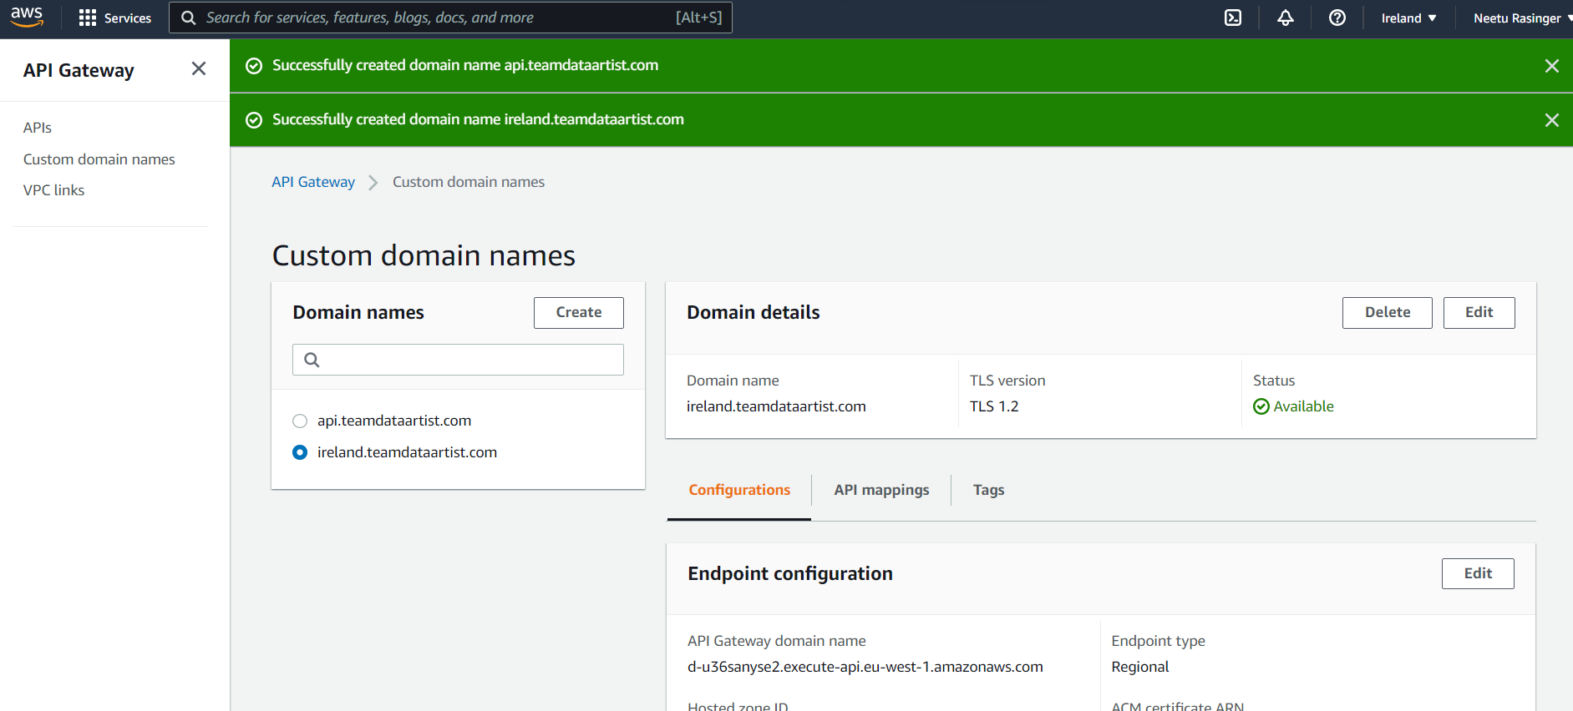

**Step 32: Repeating the above process for Singapore Region**

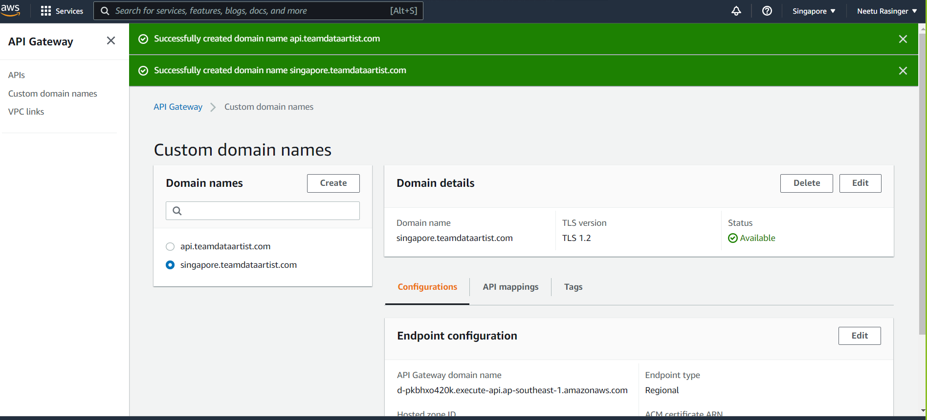

**Step 33: configuring the DNS records.**

* **In this step we will configure the CNAME records for Ireland and Singapore region.**
* **For this we clicked on create record set and then created the cname for Ireland region.**
* **We also set the TTL for 60 seconds. Next, we repeat the same steps to create a CNAME for Singapore region**

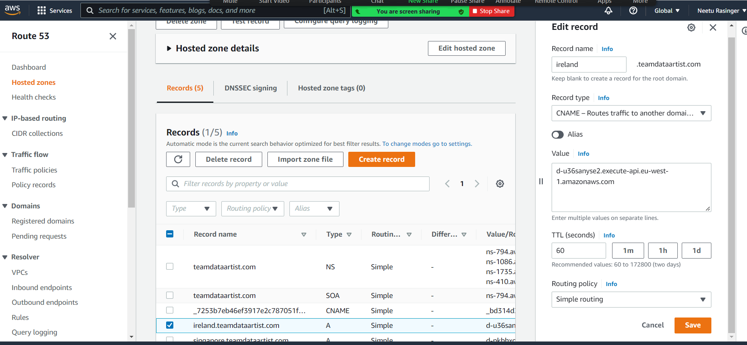

**Step 34: Configure the health check for both regions (Ireland and Singapore).For this configured Route53 health checks for regional endpoints. This health check is responsible for triggering a failover between the 2 regions if a problem is detected in any region.**

* **Navigate over to the Route53 service and selected Health checks**
* **Once configured, we can check the status. The green color says Healthy in the console**
* **We have to make sure this is green and healthy before proceeding further**

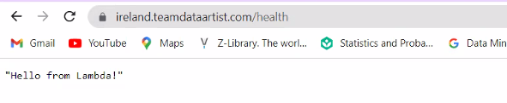

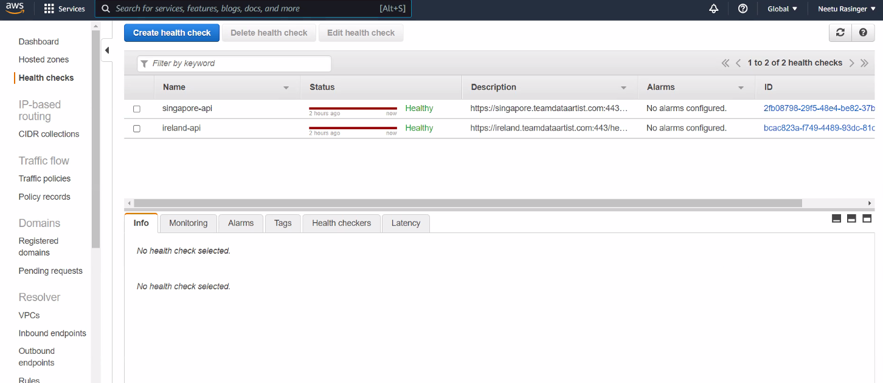

**Step 35: configuring the zone records for our api. subdomain prefix. We configured as CNAME ALIAS records in a “weighted” pattern using the health check for Multi-region active-active backend**

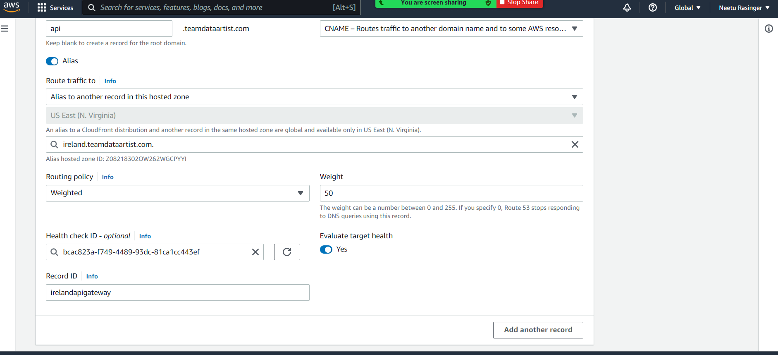

**Step 36: Updating the UI with new API Gateway Endpoint.**

* **We edited the environment.ts file and used “**[**http://api.teamdataartis.com/**](http://api.teamdataartis.com/)**” instead of region-specific name**
* **we executed “npm run build command” from the *2_UI* directory**
* **Then uploaded the */dist* contents to the S3 bucket using the same *aws s3* command we used in the second module**

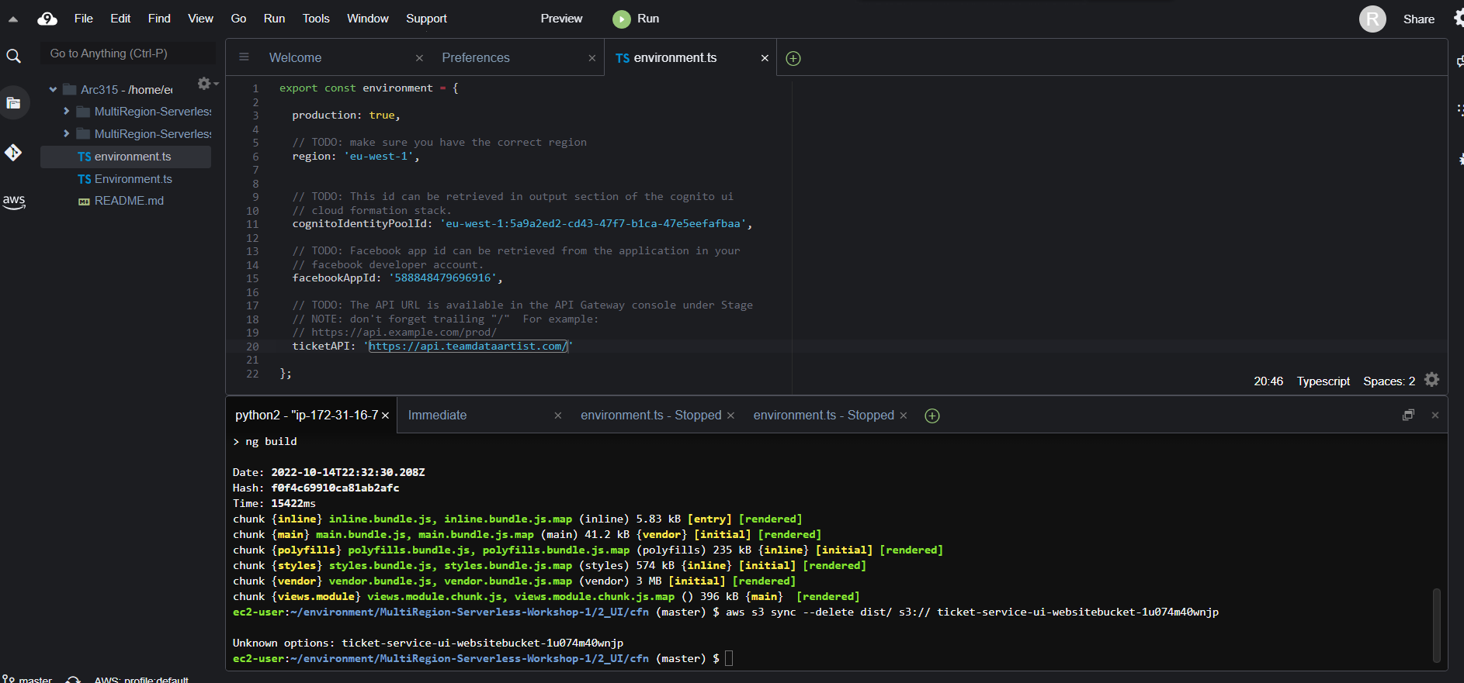

**Testing Multi-region Active-active**

**Step 37: In the AWS console, we selected the Ireland region then navigated to the API gateway.**

* **Selected the API and the GET method of the health endpoint**
* **Under Integration Request, we changed integration type to lambda function**
* **This function expects to be called with Json function containing new ticket information**

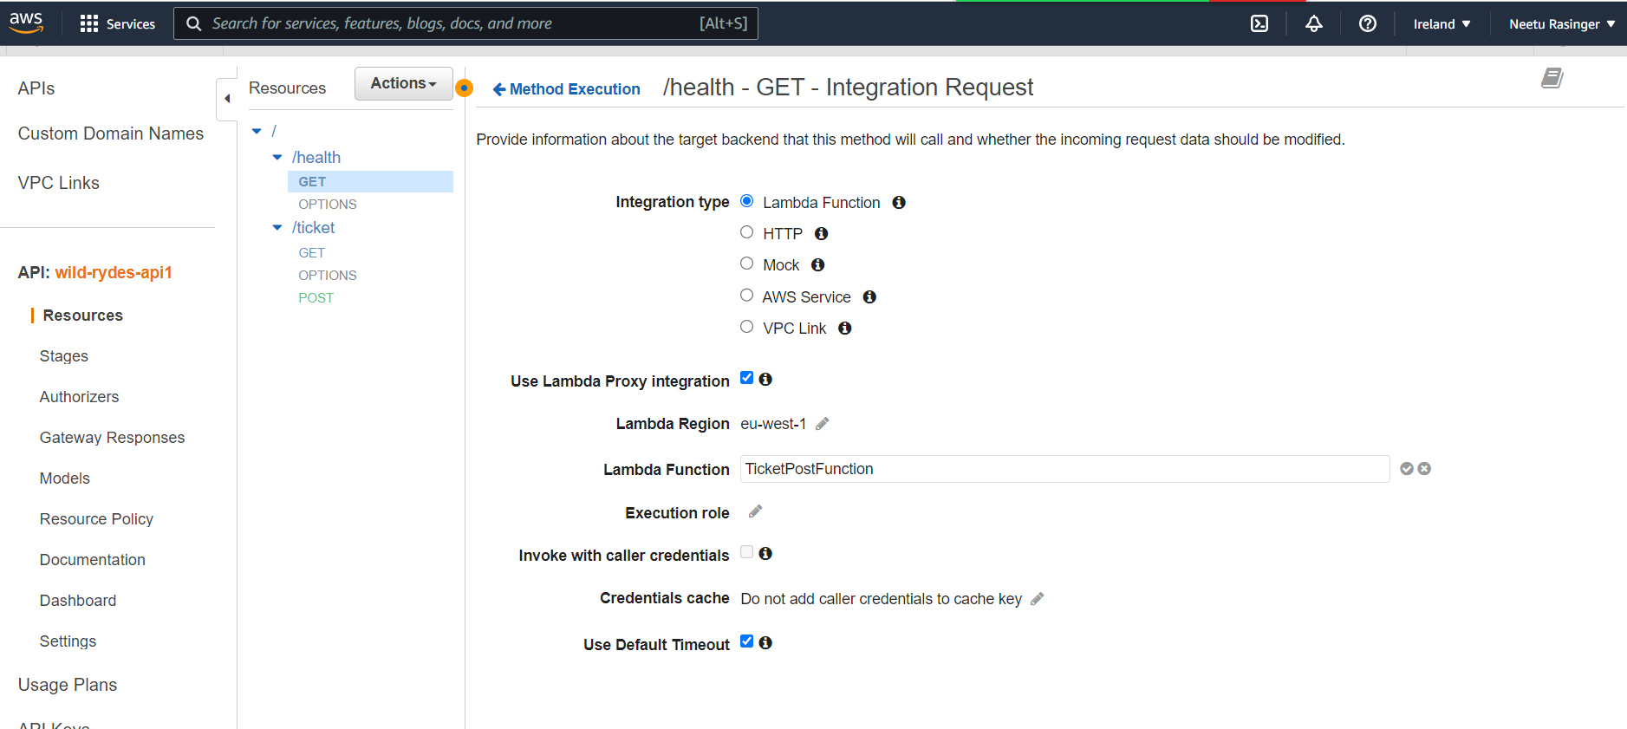

**Step 38: Verifying the failure. After intentionally configuring the GET method with POST function. We found that Ireland- API was unhealthy. For this reason, the api settings change automatically from Ireland Servers to Singapore Servers.**

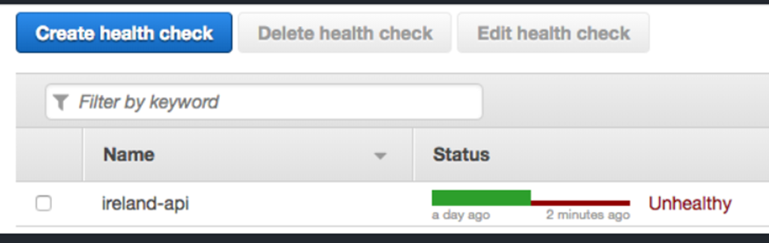

**Step 39: Using the cloudfront link, we were able to check whether the Ireland server was responding to the Singapore server or not.**

